Large Print

Widening Engagement Report (Full)

Richie Turner and Associates
A research report looking at the reasons why D/deaf, disabled, learning disabled and neurodiverse people do not attend arts events or visit National Museums’ Wales or attend very infrequently.
August 2021

Contents
Executive Summary 3-15
- Aim and Scope of Research 16-20
- Research Project Team 21-26
- Support and Guidance 27-28
- Definitions 29
- Methodology 30-36
- Research Study findings: 37-66
6 A. Online Surveys 37-41
6 B. Facilitated discussions 41-66
- Recommendations 67-77
7 A. How to make things better in the future? 67-70
7 B. Ways to improve services & reduce
barriers to attendance 70-77
- Conclusions 78-88
- Illustrated Stories 89-103

Executive Summary

Aim and Scope

Overall aim of research: To deliver a series of stakeholder conversations about widening creative and cultural engagement with communities across Wales. Aim of our research: To deliver a series of stakeholder conversations about widening creative and cultural engagement with D/deaf, disabled, learning disabled and neurodiverse people across Wales.
The Brief: Arts Council of Wales (ACW) and National Museums Wales (NMW) are committed to the principle of cultural democracy, and for the communities across Wales to be more meaningfully involved in informing and shaping our work and the initiatives they develop and deliver.
Research has shown that, despite targeted initiatives, neither ACW nor NMW are reaching as deeply into communities who face the greatest disadvantage as they would wish. ACW needs to hear what Deaf/disabled people have to say about engaging in creative cultural activity, and what support might look like if they’re to be enabled to do this. ACW would like to know what it might look like, how it could be organised and how it would widen arts and cultural engagement.
NMW is currently developing its ten-year strategy and this research will also directly inform its future plans and methods of working. ACW is also developing a longer term engagement programme and looking for this work to help shape this. Communities themselves must be the focus of this research; understanding better the interests, ambitions, frustrations of those who, for whatever reason, choose to believe that the arts “aren’t for them” and choose not to use NMW as a resource.

Research Project Team

- Richie Turner - Lead Consultant
Roles: Overall project management, research methodologies, data analysis and report writing
- Trevor Palmer
Role: Lead consultant for research with disabled people including learning disabled people
- Jonny Costen
Role: Lead consultant for research with D/deaf people
- Mary Allen
Role: Consultant for research with people with learning disabilities who are also non-verbal communicators
- Lyndy Cooke
Role: Project management, financial management and respondent liaison

Definitions

The term ‘disabled’ in the context of our research covers people who self-define as D/deaf or otherwise sensory impaired, as neurodiverse, as physically impaired or as having a learning difficulty or cognitive impairment and who experience socio-economic barriers related to their impairments. However, we have commonly used the terms D/deaf and disabled, and sometimes learning disabled, throughout the report as most of our research focussed on these 3 groups of people to engage with.
We also fully adopt the Social Model of Disability and aim to combat and eliminate ableism in our actions and terminology.
For the purposes of this research and report, the word ‘D/deaf’ is used as a general term to cover all types of deafness and hearing-loss.

Research Methodology

Shared Lived Experience
Two of the research team have shared lived experiences; one being a severely disabled person (a wheelchair user requiring a carer/Exec PA/ companion support) and one being a D/deaf person.
All facilitation activities were led by these two people:Trevor Palmer and Jonny Cotsen, apart from the facilitation activities with non-verbal communicators, which were led by our specialist facilitator in this field, Mary Allen. Ensuring that our D/deaf and disabled participants engaged with people with similar lived experiences was a key principle in our research methodology.
The research was undertaken between October, 2020 and March 2021. Our research engaged with people across all regions of Wales.

COVID19 restrictions
All research had to be undertaken by telephone and online video calls due to COVID19 restrictions. The pandemic also impacted on response rates from both organisations and individuals.
Our research has taken place trilingually: i.e. in Welsh, English and BSL.

Responses

Type | Direct interviews | Target | Achieved
Interviews | Individuals | 50 people | 32 people
Interviews | Focus Groups | 25 people | 61 people
Total interviews | Total | 75 people | 93 people
Online Survey | D/deaf & Disability  Orgs | 100 | 15 organisations
Online Survey | D/deaf & Disabled individuals | 200 | 32 people
Online Survey | Family carers  /support workers | 50 | 9 people
Total Surveys | Total | 350 | 56 responses

Research Findings
The aim of our research was to primarily seek reasons why D/deaf, disabled, and learning disabled people do not attend arts events or visit National Museums’ Wales or attend less infrequently?
Secondary objectives have tried to identify key areas for improvement or new ways of providing services, as well as examining how any new initiatives or programmes developed by ACW and NMW should be developed and implemented.

Online surveys
The key themes and trends identified:

Disabled people
- Low or no attendance at arts events are commonly caused by either a lack of confidence that venues understand the needs of D/deaf and disabled people or a lack of accessible performances
- Low or no attendance at NMW tends to be a lack of targeted participatory events or bad experiences from previous visits where staff were not helpful or supportive.
- 60% of respondents weren’t aware of the range of arts events and activities that they could attend locally and 73% of respondents weren’t aware of the range of events and activities that NMW offer locally that they could attend or participate in?

D/deaf people
- Low or no attendance at arts events is often due to a lack of BSL supported services around the actual event, or a lack of subtitles, or written scripts for theatre shows.
- Only a third of D/deaf people had visited a National Museum and the common reasons for non-attendance were a lack of advertising, no explanation as to whether events are BSL supported, previous lack of any accessible supported events.
- 63% of D/deaf people said they were not aware of the range of arts events and activities that they could attend locally and 82% of D/deaf people said they were not aware of the range of events and activities that NMW offer locally that they could attend or participate in?

Disability led / support organisations
- There was a marked difference between groups engaging with arts activities (43% said they do) compared to those who have visited a National Museum (at only 14%).
- Far more organisations were aware of arts events their members could attend than were aware of accessible events and activities at National Museums.

Carers and families of D/deaf and disabled people
- Attendance at arts events or attending NMW with a D/deaf or disabled family member was higher than expected - averaging at 63%, with awareness of suitable arts events was also higher at around 50% of respondents.
- For events at NMW only 25% were aware of suitable events and activities, with a lack of publicity about such events being the main reason cited.

D/deaf led or support organisations
● 75% of organisations engage in arts activities yet only 37% of their members have visited any of the National Museums.

Facilitated interviews
Our research has identified these 8 key themes relating to why D/deaf, disabled, learning disabled and neurodiverse people do not attend or attend arts events and museums infrequently through 121 and group interviews.

- Difficulties in making bookings at both venues and museums
- Lack of awareness of information about whether the event is accessible
- Events or programmes are not suitable and /or a lack of knowledge about suitable events/venues that D/deaf and disabed people could attend or previous bad experiences.
- Timing of events is wrong
- Worries about or lack of access support services mean people don't bother trying to attend the arts or visit a museum
- Museum or arts venue staff are rude or unhelpful or lack awareness of the needs of D/deaf, disabled and learning disabled people
- Transport issues make attending very difficult or impossible or too expensive
- Concerns that their personal support needs will not be actually catered for - this can be based on actual experiences or perceptions.

Recommendations

How to make things better in the future?
We also asked our respondents a series of questions around what types of arts activities and museum exhibits they would enjoy; who would they prefer ran these activities; should the activities be only for D/deaf and disabled people or open to everyone; who should run and manage any new fund for these activities and what objectives and targets should be put in place for the fund?
What types of arts events and activities would you like to attend or participate in?
All artforms were mentioned, but the need to keep also producing online events when live events restart was very important to many people.

What types of events and activities would you like to attend or participate in at the National Museums?
As well as lots of practical suggestions the key theme was for more interactive exhibits (that can be touched), immersive experiences and sensory events were suggested by the majority of people. Moreover:
- 66% would prefer the events open to everyone
- 40% wanted D/deaf and disability organisations to deliver these services
- Exactly 50% wanted these to be delivered as a co-produced partnership with arts organisations
- 90% want specific funds to be co-produced and managed in partnership with D/deaf and disability organisations and ACW and NMW.

Ways to improve services and reduce barriers to attendance
We also asked all interviewees for their suggestions to improve services and reduce/remove barriers to attendance and participation. We have identified 10 key areas for improvement and change.
- Online events
- Increase interactivity
- Increase provision of all forms of accessible information
- Make use of technology to improve access
- Increase and improve access communication support significantly
- Make accessible events more regular and locally provided
- D/deaf and disability awareness training and other venue support services
- Create more D/deaf and disabled artists in all artforms
- BSL: Lobby the Welsh Government to introduce a D/deaf Language Act and make BSL the third language of Wales.

Conclusions

Perhaps the first thing that stands out is the similarity of our findings to The Seven Inclusive Principles (published in 2020) by a range of disability organisations and artists.
In addition, our research points to these five key conclusions:
- Arts sector appears ahead of the cultural heritage sector
- Both arts and cultural heritage sectors have along way to go before they are reaching the majority of D/deaf and disabled people in Wales
- Arts organisations, especially venues, have highly variable support services for D/deaf and disabled people
- Building trust and fully recognising feelings of isolation
- D/deaf and disability access support, in all forms, has to become the norm
Lastly, in summary, the majority of the report is written directly from the actual voices of D/deaf and disabled people, here are a few key examples. These people and communities want to engage more and genuinely want to make change happen, but also want and need to see significant changes in policy and spending priorities, otherwise there is a likelihood their responses will again lead to no obvious change.
“If I want to book something I have to do it by phone because I cannot book ‘disabled spaces’ online. I would like to be able to do it all online. This makes it difficult because I have to make sure the date fits in with my carer. I can book online if I become a member [of a theatre] but I don’t want to be a member. I can’t even book a disabled parking space online. It would be easier if I could do it all online”.
“It's really hard to find out what’s on, even within accessible and access forums for various types of disability, we struggle to know where it is, how we can find out what’s on and whether it's accessible”.
“Wording in museums is too difficult to understand and it’s embarrassing when I have to ask my carers to explain things to me or read to me in public”.
“I have got to the point now, where for example, like Sherman 5 get in touch but I don’t open the emails anymore because I feel 99% of the time it’s not stuff for me. They're advertising things that don’t have access.”
“They tend to have BSL on one day, the captions on another day, the austic friendly performance on another day. So if you fall into all those 3 categories you can’t attend with your friends or others from a [D/deaf/disability] group. You have to split up and go on different nights''.
“I have gone to bigger venues and sometimes it’s okay, but you're taking a chance each time on whether or not the quality of the sound will be good enough and a lot of places if you do use the hearing loop it’s not been serviced and it’s not actually working.“
“I know a lot of places ask about access needs but not everyone seems to understand what that really means to us.”
”It seems to take up so much time [asking for help or availability of access facilities] because people just have to go and speak to other people and then come back to you and then say yes or no, we can or can’t do that”.
“The two biggest barriers for me are getting to venues and finding accessible venues that I can actually get to”.
“In Wales not enough arts venues have audio-descriptions of exhibitions. The lack of provision for me is a big barrier. I have to have someone with me to explain things all the time. Without that support I can’t attend”.
“I need to have support to attend venues and if I do not have enough hours to pay for support in my care plan I am stuck at home. The same applies to visiting museums”.
“The effort and time needed to get my act together to simply attend an arts event is often too much for me”.
“The lack of choice of being able to select an accessible venue or museum puts me off in general”.
”It’s about education. It’s about being kind to each other and creating a human connection”.
“It's always that after thought, that's what the problem is, it's like you know you have all these people at the moment and we're advocating when people go and put in an application to funding we always say ‘Put in something for communication support. If D/deaf people don't come to you, you can give that money back but you can't ask for it once you've started.’ And it is almost as if people go, we've done all this and this and you put your hand up and go accessibility for BSL users? And they go oh we didn’t think about that... You wouldn't expect someone - who uses a wheelchair - to bring their own ramp! So why not provide for us too?”
“I think access, you know, needs to be something that is up there in front, on your advert. On your invitation, it needs to be there. People need to be honest as well. If there is no access, just say it”.
“The perfect scenario is you turn up, open the doors, the person who greets you will know, understand if you say I am D/deaf and I will use sign language or I am D/deaf and struggling with my eyesight. They say, come with me and I will take you, that happens in some places. But it usually depends on the individual. So what I tend to find is sometimes it is not the venue itself it is the just strike lucky with an individual, either trained or know somebody who is D/deaf and they know what to do”.
“Equal access will never be possible unless disabled people are prioritised with improved access to all people”.
“Things will only ever change if we all work together”.

1. Aim and Scope
1.1 Overall aim of research:
To deliver a series of stakeholder conversations about widening creative and cultural engagement with communities across Wales.
1.2 Aim of our research:
To deliver a series of stakeholder conversations about widening creative and cultural engagement with D/deaf, disabled, learning disabled and neurodiverse people across Wales.
1.3 Background to the research (taken from tender brief)

The COVID-19 crisis has significantly changed the world we live in within the space of a few months. Arts Council of Wales (ACW) and National Museums Wales (NMW) seek to provide more meaningful involvement enabling communities to inform and shape their work.
One of their most important priorities is to encourage more people and a wider range of people to enjoy and take part in culture and the arts, and to develop and support initiatives which display a robust commitment to connecting with wide and diverse audiences.
ACW wants the arts in Wales to be rich and varied, to reflect Wales’ many different communities, and to engage with diverse audiences and participants. The principles of this approach are set out in ACW’s corporate plan, “For the Benefit of All”.
As a free entry national museum, NMW wants to increase participation and ensure more equitable representation and use of our resources. They want to ensure that people and communities have direct access to, and the right to participate in, the culture of their selection. NMW is committed to embedding a cultural rights-based approach, inspired by the United Nations Declaration of Human Rights. The principles of this approach are set out in their vision, “Inspiring People, Changing Lives”.
Their collective vision is of a culture and arts sector in Wales that is naturally bilingual, inclusive and diverse, and more vibrant, exciting and relevant because of this. Public funding for culture and the arts has many purposes: to increase choice, to subsidise costs for audiences and participants, to support skills development, learning and well-being, to encourage innovation and risk-taking, to invest in those activities that the commercial sector either won’t, or isn’t able to, support. But it also recognises a whole society’s right to share and participate in its cultural achievements.
Arts and culture in Wales will be stronger, more exciting and more relevant if it embraces more people, and ACW and NMW recognise the dynamic force of art and culture that is truly inclusive and makes use of the talents of all members of our society. Yet in spite of their efforts over many years, the simple fact is that the benefits of public investment in culture and the arts remain stubbornly limited to a small proportion of the population (usually the wealthiest, better-educated and least ethnically diverse). This is what ACW and NMW want to try and change.
ACW and NMW want to be part of a society in Wales that embraces equality and celebrates difference, wherever it’s found, in race, gender, sexuality, age, language, disability or affluence: Because a generous, fair-minded and tolerant society is instinctively inclusive and values and respects the creativity of all its citizens.

1.4. The Brief

ACW and NMW are committed to the principle of cultural democracy, and for the communities across Wales to be more meaningfully involved in informing and shaping our work and the initiatives we develop and deliver. They are committed to deep and meaningful engagement with communities, particularly those who feel separated or disconnected for a number of reasons – including, but not restricted to, economic, social and geographical considerations.
Research has shown that, despite targeted initiatives, neither ACW nor NMW are reaching as deeply into communities who face the greatest disadvantage as they would wish. They have recognised they have more to do to ensure equality of opportunity across communities.
In 2019 Arts Council of Wales commissioned support to undertake a piece of work to look internally at the community and engagement work they’ve been supporting and delivering across Wales. The purpose of this exercise was to identify common features across the range of work and suggest ways in which this aspect of their work could be improved. The conclusions drawn suggested that there’s an important piece of worK that is needed. This is what ACW has now commissioned.
In time, ACW wants to have a strategic collaborative programme, across organisations, that promotes broad and inclusive engagement with our communities that currently face the greatest disadvantages. But before that happens, ACW needs to hear what those community stakeholders themselves have to say about engaging in creative cultural activity, and what support might look like if they’re to be enabled to do this.
ACW has determined they are not necessarily the right people to do this work and so have commissioned this independent research.

This work will involve engaging with a range of community groups and representatives to identify what these communities themselves would want from a programme designed to fund and/or support creative activity in their locality. ACW would like to know what it might look like, how it could be organised and how it would widen arts and cultural engagement.
NMW is currently developing its ten-year strategy and this research will also directly inform its future plans and methods of working. ACW is also developing a longer term engagement programme and looking for this work to help shape this. Communities themselves must be the focus of this research. They aren’t looking for a piece of work that simply identifies those who ACW and NMW routinely work with. They are particularly interested in understanding better the interests, ambitions, frustrations of those who, for whatever reason, choose to believe that the arts “aren’t for them” and choose not to use NMW as a resource.
Of course, communities across Wales are not homogenous. Different communities will have distinct identities defined by language, locality, gender and ethnicity.
There will be many reasons, therefore, why people will feel that they face barriers to enjoying and taking part in culture and the arts.
The types of activities to be undertaken could include:
- Work with community representatives and/or relevant groups to hold creative conversations and gather views on what creative and cultural engagement does, or could, look like.
- Suggest types of support, and ways of working, that might help to improve or increase opportunities. (Using the Five Ways of Working, as outlined by the Future Generations Commissioner for Wales, as a framework for this work. These are long-term, integration, involvement, collaboration and prevention).
- Identify the key potential elements of a strategic programme to widen cultural and arts engagement across Wales, and particularly with communities that currently face the greatest disadvantages. (It is essential that such an assessment is derived directly from meaningful interaction with these communities).

2. Research Project Team

Richie Turner - Lead Consultant
Roles: Overall project management, research methodologies, data analysis and report writing
Richie spent 9 years as a Member (Trustee) of the Arts Council of Wales and Chair of their Equalities Monitoring committee. He has worked in the fields of arts, cultural and creative industries for over 30 years as both a staff member and a freelance consultant and has held senior roles such as Head of Arts Revenue Lottery for the Arts Council of Wales (where he jointly developed ACW’s first Cultural Diversity Strategy in 2000), was the first Nesta Director for Wales and was a founder of the award winning Nofit State Circus. Richie also spent 5 years as Director of Wales’ first culturally diverse arts development agency CADMAD, which is where he began his long standing work with diverse communities across Wales. He is currently Incubator Manager for the University of South Wales and a lecturer for MA Arts Management at the Royal Welsh College of Music and Drama. He is a Non-Exec board member for Creative Wales, Creative Cardiff, Newport Live and Gentle/Radical.
Richie has undertaken many large scale research consultancy projects for arts and creative industries clients. Most recently, alongside Trevor Palmer, Richie has led a major UK feasibility study for the 4 UK Arts Councils and the BFI into the establishment of a UK wide arts access card scheme. Other work has included supporting the development of the Diversity Action Plan for Theatre in Wales for BECTU in 2019, and an Innovation Review for S4C in 2011.
Richie is now an Arts Associate for ACW in the policy fields of community arts and widening engagement.

Trevor Palmer
Role: Lead consultant for research with disabled people including learning disabled people
Trevor is a South Wales based entrepreneur, with over 30 years business experience. Trevor has severe mobility difficulties and is a wheelchair user and requires a care assistant to enable him to work and travel. Trevor’s passion lies in promoting employment opportunities and independence for disabled people.
He has fulfilled this both as an employer of disabled people and as a Welsh Government and Young Enterprise business mentor. He was contracted to run the Disability Advisory Group of the Wales Millennium Centre during its construction and fitting out.

Trevor is undertaking his second period as a Board Member for Disability Wales, in addition to roles on the Newport Access Group and the Social Services National Partnership Board for Wales. He has just completed working alongside Richie again for the UK Arts Councils commissioned feasibility study into establishing an arts access card scheme, where his role was to identify and engage with disability led organisations throughout the UK.
With a career as a fashion designer that took him all over the world, Trevor now maintains his global links through ResponsAble Assistance, providing support for disabled people in disaster situations worldwide. Trevor’s approach to life is inspired by the social model of disability, equality and independent living as essential human rights. Trevor is also a co-founder of See Around Britain - an app that details the access facilities and services of arts and tourism venues across the UK.

Jonny Costen
Role: Lead consultant for research with D/deaf people
Jonny wishes to state that English is not his first language and is only a spoken language.
Born in Cardiff Jonny is a qualified graphic designer and teacher but has left his professional career to develop himself as a performance artist, facilitator and consultant for inclusion in the arts. Jonny developed and wrote the ACW Toolkit for venues and theatre companies, which provides guidance on how to improve access for D/D/deaf, D/deafened and hard of hearing audiences in Wales.
Jonny also runs inclusive drama workshops and is a D/deaf Equality trainer for people with and without disabilities, and is a trustee for Disability Arts Cymru. Jonny is currently an artist in residence with Pervasive Media Studio based at the Watershed in Bristol working on a new immersive theatre piece which is designed for social change.
He does public speaking and enjoys being on panel discussions on access provision in the arts with Unlimited Connects and at other events. In 2019 he completed a successful run at Edinburgh Fringe with ‘Louder Is Not Always Clearer’ and would have been touring across the UK and Europe in 2020/21 (tour currently cancelled because of COVID-19). His other performing credits include: ‘English' (Quarantine and National Theatre Wales), ‘Ways Of Being Together’ (Jo Fong), Cardiff: City Road Stories (Sherman Theatre).
Jonny has received ACW Together Stronger funding to strengthen D/deaf Artist networks in Wales and develop a D/deaf Artists Network. Moreover he has awarded Stabilisation Funding (Individual) for ‘D/deaf Cafe Conversations’ to support his research into lived D/deaf experiences about culture, education, medical, history and activism. The sessions will be recorded and collated for further research.
Over the past 4 years he has worked with many individuals and organisations delivering specialist advice on equality, access and inclusion as it is in the heart of how we should be making creative work. One of his main focuses was the National Museum and Gallery, where he co-produced and planned with Melissa Hinkin at Artes Mundi a BSL curated event which was sold out. No-one who attended the event had ever been to the museum before. Jonny also set up the D/deaf Theatre Club funded by Sherman 5 and was recently selected as part of the Nesta Y Lab / ACW 'HARP' (Health, Arts, Research, People) innovation programme to commissioned six D/D/deaf and or disabled artists to make short online artworks in response to their experience of the pandemic and hopes for the future.

Mary Allen
Role: Consultant for research with people with learning disabilities who are also non-verbal communicators
Mary has worked in a number of roles with adults with a learning disability for the past twenty years throughout Wales and currently works for Adult Learning Wales where she teaches adults with a learning disability.
Mary founded Monmouth People First with a colleague and facilitated and developed the group for many years. Her work has highlighted the need to increase communication and participation for adults with more complex communication and mobility difficulties, and she has worked on a variety of projects over the past few years aimed at addressing the barriers to inclusion for this cohort. This has included collecting stories for ‘Measuring the Mountain’ (http://www.mtm.wales/) where carers and disabled people’s stories were collected together using different research methods such as video diaries to document their lives.
Most recently Mary has been working with young people with learning disabilities in Torfaen on a project called ‘Unheard Voices’. This project aims to understand the needs and opinions of people through non-verbal communication methods such as the award winning Talking Mats (where she is a registered trainer). For example, the ‘Unheard Voices’ research included asking young people if they wanted to go to the theatre? Mary has a Master degree in Specific Learning Difficulties and is a fully qualified adult education teacher.

Lyndy Cooke
Role: Project management, financial management and respondent liaison
Lyndy is a highly experienced events producer, programmer, curator and a freelance international consultant for arts and cultural events. She was Managing Director for Hay Festival for 20 years, retaining an honorary role within the festival.
Now extensively involved with organisations such as the National Trust, British Council, Arts Councils in UK and Ireland, Commonwealth Foundation, Queens
Park Book Festival, Jaipur Literature Festival in India, York Festival of Ideas, Ubud Writers & Readers Festival in Bali, where she develops international cultural, artistic and business relationships using her extensive knowledge of the cultural, charitable and commercial worlds. She specialises in financial management and events programming and scheduling.
She is also a founding Director of the recently launched Love Reading Lit Fest, a co-Director of Handheld Events and to keep her grounded, Lyndy, with her business partner at Hooftrek, also has a large herd of ponies that she has trained to be faithful pack ponies, leading guests and carrying their equipment across the Cambrian Mountains and Brecon Beacons to enjoy the stunning scenery and the great Welsh outdoors.

3. Support and guidance
We wish to thank the following for their support and guidance during the research. Without such support we would not have been able to achieve the high level of engagement and reach that we are delighted to report on.
The Research Project Board:
- NMW: Nia Williams, Owain Rhys, Elaine Davies and Nasir Adam
- ACW: Diane Hebb, Amanda Loosemore, Hilary Farr and Janine Reynolds
- Re:cognition: Jon Luxton and Lu Thomas
- Welsh Arts Anti Racist Union members
Andrew Miller - UK Government Disability Champion for the Arts & Culture, and Council Member for both ACW and Arts Council England for his overall guidance and advice.
Translation:
- Francesca Dimech - Welsh Language translations
- Helen Foulkes – BSL translation and videos for the online surveys
Access support for 121 and group interviews:
- Claire Anderson – BSL Interpreter
- Maclean Real Time (Hilary Maclean) - Captioning
- Live Captioning UK Ltd (Sheryll) – Captioning
- Samantha Boyd – Captioning
- Anthony Evans – BSL Interpreter

Illustrations:
- Ian Cooke Tapia and Cooked Illustrations
Most importantly we wish to thank all the individuals and organisations who have given their time and views through our online surveys and facilitated interviews. Without your contributions we would have nothing to report on.

4. Definitions
The term ‘disabled’ in the context of our research covers people who self-define as D/deaf or otherwise sensory impaired, as neurodiverse, as physically impaired or as having a learning difficulty or cognitive impairment and who experience socio-economic barriers related to their impairments. However, we have commonly used the terms D/deaf and disabled, and sometimes learning disabled, throughout the report as most of our research focussed on these 3 groups of people to engage with.
We also fully adopt the Social Model of Disability and aim to combat and eliminate ableism in our actions and terminology.
For the purposes of this research and report, the word ‘D/deaf’ is used as a general term to cover all types of deafness and hearing-loss.

5.Research Methodology

Shared Lived Experience
Two of the research team have shared lived experiences; one being a severely disabled person (a wheelchair user requiring a carer/Exec PA/ companion support) and one being a D/deaf person.
All facilitation activities were led by these two people:Trevor Palmer and Jonny Cotsen, apart from the facilitation activities with non-verbal communicators, which were led by our specialist facilitator in this field, Mary Allen.
Ensuring that our D/deaf and disabled participants engaged with people with similar lived experiences was a key principle in our research methodology.

Timescales
The research was undertaken between October, 2020 and March 2021.

Trilingual
Our research has taken place in Welsh, English and BSL.

Geographical spread
Our research engaged with people across all regions of Wales.

COVID19 restrictions
Clearly undertaking this research during the COVID19 pandemic has meant that our original hopes to undertake some socially distanced face-to-face interviews and group discussions could not happen.
We fully recognise that many disabled people are still shielding including one of the research team. For D/D/deaf people we also recognise that the wearing of face masks means they may be unable to lipread in a face-to-face interview environment and therefore all of our facilitated sessions (except for 3 interviews with non-verbal communicators which did place in their homes under strict H&S rules) have been undertaken via Zoom video calls or phone calls.
Moreover, because of the pandemic, and its impact on the daily lives of many isolated D/deaf and disabled people, some of our proposed research methodologies failed to achieve the engagement levels we had hoped for. For example, plans to run creative, participatory activities that would have also allowed conversations around our research at the same time were obviously impossible to deliver.
But the pandemic also impacted on some of the research methodologies which we were still able to undertake. For example, our direct email marketing and engagement to over 100 D/deaf and disability led/support organisations across Wales did not result in the anticipated number of survey responses. We believe this was largely for two reasons: organisations had either temporarily closed and put all (or the majority) of staff on Furlough and hence simply did not respond to our multiple email campaigns, or organisations were too busy dealing with COVID19 related issues to have time to engage with our research.
This is a disappointment to us, although it would be possible to rerun these surveys once we are back to some form of normality, if ACW and NMW wanted further evidence to back up our current research findings.
We also received some feedback that response levels were low due to ‘consultation fatigue’. This is not the first time D/deaf and disabled people have been consulted about public service delivery, or even more specifically arts and cultural heritage services. Failures to deliver major policy or organisational changes, or at least perceptions that ‘their voices have been ignored’ must be addressed with the overall findings for the whole of the Widening Engagement research.

121 and Group Interviews

However, despite these setbacks we were able to achieve the following levels of responses for our 121 and group interviews, which are overall above our original target.
Direct interviews | Target | Achieved
Individuals | 50 people | 32 people
Focus Groups | 25 people | 61 people
Total | 75 people | 93 people
Disability or D/deaf led /support Organisations | Not specified | 9
Facilitated interviews with (individuals and groups) for disabled and learning disabled people | 30 sessions | 20 sessions
Facilitated interviews with (individuals and groups) for D/deaf people | 25 sessions | 11 sessions
Facilitated individual interviews with learning disabled non-verbal communicators | 5 sessions | 3 sessions

Online surveys
We created 3 online surveys aimed at D/deaf and disability led organisations, D/deaf and disabled individuals and family carers / support workers of D/deaf or disabled people. Each of these surveys were available tri-lingually.

English
The link to the disability led organisations survey is here:
https://www.surveymonkey.co.uk/r/LXPCGVQ 7 responses
The link for survey of disabled individuals is here: https://www.surveymonkey.co.uk/r/LN6YYWR 15 responses
The link for the family carers/support workers of disabled people survey is here: https://www.surveymonkey.co.uk/r/LFCPMST 7 responses

Welsh Language
The link to the organisations survey is here: https://www.surveymonkey.co.uk/r/LGM59N3 0 responses
The link for survey of disabled individuals is here: https://www.surveymonkey.co.uk/r/LG5K58S
1 responses
The link for the family carers/support workers of disabled people survey is here: https://www.surveymonkey.co.uk/r/LGHJLBW
1 response

British Sign Language :
The link to the D/deaf organisations survey is here:
https://www.surveymonkey.co.uk/r/NV57TLW 8 responses
The link for survey of D/deaf individuals is here: https://www.surveymonkey.co.uk/r/BJ8M8DM 16 responses
The link for the family carers/support workers of D/deaf people survey is here: https://www.surveymonkey.co.uk/r/RW5L7XD 1 response

Total survey responses: 56
This is significantly below our original target of 500 responses, however the primary purpose of the surveys was to raise awareness of our research through our targeted email campaign to organisations and from there to identify eligible participants for the 121 interviews and focus groups.
Given that our overall target to interview at least 75 people has been achieved we are relatively confident that our research findings are an accurate reflection of the views of D/deaf and disabled people who are not regular attenders of the arts and National Museums in Wales.

Desk Research

We reviewed some relevant policy, strategy and project reports from both NMW and ACW including:
- For the Benefit of All: ACW
- Annual Equality Reports 2018-19, 2019-20: ACW
- 64 Million Artists Report: ACW
- Seven Inclusive Principles for Arts & Cultural Organisations: endorsed by
ACW
- Inspiring People, Changing Lives: NMW
- Case Study Engagement and Volunteering 2019-20: NMW
- Annual Equality Report April 2019:NMW
- Community-Engagement-Strategy 2015: NMW
- Staff training report: NMW
- Hands on Heritage Report 2019-2020: NMW
- Visitor Survey 2015-2016: NMW
- Public Engagement and Consultation Report 2012: NMW

Reporting in their own words

We have decided, where it is possible, to quote our respondents directly rather than simply summarise their viewpoints. We hope this provides greater understanding and authenticity to our findings. Obviously we have reported these quotes anonymously, apart from a few instances where the response was from a group and therefore not attributable to any individuals.

6. Research Findings
The aim of our research was to primarily seek reasons why D/deaf, disabled, learning disabled and neurodiverse people do not attend arts events or visit National Museums’ Wales or attend or visit infrequently.
Secondary objectives have tried to identify key areas for improvement or new ways of providing services, as well as examining how any new initiatives or programmes developed by ACW and NMW should be developed and implemented.

A. Online surveys
The key themes and trends identified:

1. Disabled people
● Low or no attendance at arts events are commonly caused by either a lack of confidence that venues understand the needs of D/deaf and disabled people or a lack of accessible performances
○ “Why are accessible performances only programmed once, often for matinees? Do venues think all disabled people don’t work and can attend any time!”
● Low or no attendance at National Museums tends to be for one of two reasons:
○ a lack of targeted participatory events for disabled people
○ bad experiences from previous visits where staff were not helpful or supportive.
- 60% of respondents weren’t aware of the range of arts events and activities that they could attend locally?
- 73% of respondents weren’t aware of the range of events and activities that National Museums Wales offer locally that they could attend or participate in?
- Despite being disabled only 53% stated they needed support to attend an arts event or visit a museum yet 73% stated they have access requirements in order to attend an arts event or visit a museum?
- Some examples experienced of difficulties attending an arts event or visiting a national museum include:
○ Overwhelmed by busyness and noise / confusion. Anxiety.
○ Lack of transport (came up many times)
○ Lack of training of staff, lack of awareness of disabled needs or perceived rudeness e.g. refused the right to sit whilst queuing
○ Lack of response to letters, e-mails or verbal requests to improve services
○ Lack of access information on promotional media and no invitation to request access needs.
○ Inaccessible venue

2. D/deaf people
- Low or no attendance at arts events is often due to a lack of BSL supported services around the actual event, or a lack of subtitles, or written scripts for theatre shows.
- Only a third of D/deaf people had visited a National Wales Museum and the common reasons for non-attendance were a lack of advertising, no explanation as to whether events are BSL supported, previous lack of any accessible supported events.
- 63% of D/deaf people said they were not aware of the range of arts events and activities that they could attend locally?
- 82% of D/deaf people said they were not aware of the range of events and activities that National Museums Wales offer locally that they could attend or participate in?
- 75% of D/deaf people stated they need support to attend an arts event or a museum with 63% stating they have access requirements too.
- Some examples experienced of difficulties attending an arts event or visiting a National Museum Wales location include:
○ Advertised loop systems often don’t work.
○ “I did once without a friend visit an Arts Gallery and when staff talked about the art to me, when the speakers finished and asked me about it I said sorry I don’t understand the speaker as I am D/deaf. Nothing happened and they left me wandering around the gallery.”
○ Lack of basic BSL awareness and D/deaf communication
○ “When myself and my Deaf visitor friends attended a National museum it was such a huge place and we couldn’t navigate our way around ourselves. We did our best to converse with staff who worked there but it would’ve been much easier and less stressful if there was some sort of BSL guide video on a tablet available or something similar. “
○ Lack of physical access remains a major issue as they are often unable to use disabled entrance as D/deaf people cannot hear the answercom systems used. Organisations don’t consider people with multiple support needs.

3. Disability led / support organisations
- There was a marked difference between groups engaging with arts activities (43% said they do) compared to those who have visited a National Museum (at only 14%).
- Far more organisations were aware of arts events their members could attend than were aware of accessible events and activities at National Museums.
- There still remains a high number of organisations that are unaware of theHynt Arts Companion Card (at 43%)
- Nearly 50% of organisations still consider that their members are not equally provided for in terms of access to services e.g. events, exhibitions and participatory activities.

4. Carers and families of D/deaf and disabled people
- Attendance at arts events or attending a National Museum with a D/deaf or disabled family member was higher than expected - averaging at 63%.
- Awareness of suitable arts events was also higher at around 50% of respondents. However that still means 50% of family or support workers are unaware of these opportunities.
- For events at National Museums though only 25% were aware of suitable events and activities, with a lack of publicity about such events being the main reason cited.

5. D/deaf led or support organisations
- 75% of organisations engage in arts activities yet only 37% of their members have visited any of the National Museums.
- Awareness of suitable arts events was 38% but this fell to only 25% for activities in National Museums.
- 75% of organisations do not feel their members receive equal provision of services such as events, exhibitions, or participatory activities.

B. Facilitated interviews
Our research has identified these 9 key themes relating to why D/deaf, disabled, learning disabled and neurodiverse people do not attend or attend arts events and museums infrequently through 121 and group interviews.

1. Difficulties in making bookings at both venues and museums
A significant proportion (about 30%) of respondents said that because making bookings is difficult or complex. Simply they feel discriminated against as they cannot book online in the same way non-disabled people can take part in such services. This has been exacerbated by the COVID19 restrictions where almost all booking activities have moved online.
Disabled people are expected to book either in person (clearly not possible during lockdown) or make a telephone enquiry and booking (not possible for many disabled people). Before the pandemic some D/deaf and disabled people preferred this option as it allowed them to reassure themselves that the venue or museums understood their needs fully (See Point 8 Support Needs), but some felt this placed an unnecessary burden on the disabled person. Since the pandemic many venues have closed their telephone booking systems and therefore this option has now also been severely restricted.
It is hoped this problem will be resolved in the near future if the 4 UK Arts Council’s take forward a proposal to establish a UK wide arts access card and booking system (we believe recommendations from ACE regarding this feasibility study are due to be announced in the next few months). This would mean all D/deaf and disabled people in the UK could register their access and support needs on a central arts access database and then when making a booking enquiry to any arts venue they would simply provide their membership details and the venue’s booking systems would automatically know their needs. A response to this feasibility study has been delayed significantly due to the COVID pandemic, so at this time of writing we are unaware of whether this proposal will be going ahead or not.
“I often have difficulties with booking devices on websites not being clear”.
“The need to book in advance makes us less likely to attend”.
“There are difficulties with accessibilities on websites”.
“D/deaf people sometimes cannot read English or Welsh … so website booking is impossible without BSL”.
“With loop systems you have to be in a particular place [in the auditorium] for it to work and as you know you have to go and book it months before hand to try and get the seating that is best so that loop works and because that’s a bit difficult I don’t go.”
“So when you book the event there is rarely a field or some kind of way that you can let people know what you need. Very often you get a link to book a place and that place could be Eventbrite or something similar where you register via one of those kinds of agencies where I have lost count of the number of times I have not been able to locate support for access needs. ‘Is there anywhere on the booking that I can make a request for access? The answer is invariably no”.
“These days it’s very rare that you go to a ticket office or you speak to people over the phone, it’s all online now.”
“We visited Cardiff Castle and they have an app to translate the guided tour into different languages. When we had finished we saw a sign saying that the app could also do BSL. Why wasn’t that information visible when we booked the visit?”.
“Access info for physically disabled people is often really hard to find on information supplied by the venue online when looking for it and considering attending”.
“Arty farty type messaging on advertising, such as Gothic and trendy typefaces also make it hard to read from a few feet away in a wheelchair”.
“If I want to book something I have to do it by phone because I cannot book ‘disabled spaces’ online. I would like to be able to do it all online. This makes it difficult because I have to make sure the date fits in with my carer. I can book online if I become a member [of a theatre] but I don’t want to be a member. I can’t even book a disabled parking space online. It would be easier if I could do it all online”.
“Disabled spaces are often dotted around and the staff at the venue decide where I will be seated rather than me selecting my space myself. I don’t like that”.

2. Lack of awareness of information about whether the event is accessible (in whatever way)
Even if the disabled person can tackle the additional barriers to make a booking, there are significant issues around a lack of information as to whether a specific event is accessible or not ? Almost every person interviewed raised this issue to some respect.
“There are no local events [which provide for my needs] so I only go on organised visits where I know my needs will be supported.”
“I need to check [if I can be supported] before going and to make people aware of my needs and check their access facilities and this is often difficult to find out”.
“Events must be marketed so that their access facilities can be easily found”.
“I try and find out what’s going on but it’s often not clear”.
“It's really hard to find out what’s on, even within accessible and access forums for various types of disability, we struggle to know where it is, how we can find out what’s on and whether it's accessible”.
“There is often poor communication with theatres [that means we don’t attend events].”
“You normally now find it’s a huge fight to speak to someone to actually get a quick answer if the event is accessible”.
“[Theatres] often don’t advertise signed performances but if a D/deaf person wants to go and they pick a performance and provide an interpreter for it. They don’t automatically say every performance they’ll provide a sign language interpreter but what they will do is provide one if D/deaf people ask. So you’ve got a group of theatre goers who know that but you’ve also got people who are not in that little group who think, well, they’re not telling me there is an interpreter, what’s the point in going? Sometimes it’s their advertising of the access that’s the problem.”
“This is conflicting [referring to the previous point] as you have to have the ability to contact the organisation, know how to contact them and who to speak to. You have got to have assertiveness as well to sort of say that I need this [support] If I don’t have it , I can’t come”.
“Barriers still exist, you know again that it is a fact that because those [signed] performances are not then advertised in good time it does mean that the wider D/deaf community are not aware of it”.
“On entry to the museum there were no notices to say if they understood simple sign language or that the receptionist was D/deaf aware. So that was the first barrier, you know, that is before you get into the museum. And as you know it makes you feel very unwelcome”.
“I only find out if an event is suitable for me via other D/deaf people not directly from the organisation making the accessible work. Finding out about accessible performances is a problem in itself”.
“I think that every time there is an advert to book tickets there should be a line saying - if you have special access needs then click here, because some theatres might be providing access. I might be missing loads of accessible events really because I simply don’t know [about them]. That’s the thing , you read an advert and there is nothing there for me, so you move onto the next thing.”
“ I get emails everyday from all kinds of promoters and things like that. Very rarely are they accessible.”
“From my experience you always had to ask if you wanted to see something. They never market them”.
Clearly there seems to be several key issues around this problem. Firstly whilst many venues are putting on accessible performances their advertising of these accessible performances is not easily found by the people they are intending to support. Surely that’s easily rectified?
Secondly, some venues are willing to help but only if a request is made. Many D/deaf and disabled people are not confident enough to make these requests individually, especially those with learning disabilities, so either miss out or remain unaware they can make direct requests. Again this seems a strange way to provide accessible services. Perhaps venues think this way of operating makes them appear responsive to need. At best it’s a reactive way to do things.
Thirdly, being proactive instead would mean actively targeting the people who might benefit from these accessible events. Reaching out to D/deaf and disability led organisations to let them know you are offering accessible performances or activities or visits should become a regular aspect of all marketing plans.

3. Events or programmes are not suitable and /or a lack of knowledge about suitable events/venues that D/deaf and disabed people could attend or previous bad experiences
There is a distinction in the minds of many D/deaf and disabled people between a lack of information about whether an event is accessible or not and whether the actual event or venue is suitable for them or not? Clearly this is a highly personal question, but many feel even if they do find out about an event, and find out if it’s accessible, they still have to choose whether when they actually attend or make a visit and if they will find the experience is pleasurable or not?
“We do try and go out, but we don’t attend many venues or museums, as there are not many places we feel comfortable visiting”.
“I can’t deal with crowds and like to have access to exhibitions or museums when few other people are present. Perhaps booking for limited visitor events if possible”.
“Some places like museums are too big, with too many people. I need less people to be able to go”.
“A great Welsh language book was turned into a Welsh language opera but the performances and post event talks were totally inaccessible. Why is this allowed?”
“So what tends to happen, the nervousness is you don’t know where the producer of the show is going to demand that the Stagetext could be- sort of at the top of the stage, which means if you are looking at the stage you literally got to to crick your neck to look up there or you’ve got to play tennis because they’ve sat you in the middle but the Stagetext is to the left or right.”
“They tend to not put the text where it should be, it should be where you want to watch a captions TV, ideally in front of the action, but they don’t like doing that because perhaps mainstream audiences wouldn’t be keen on it.”
“Some of the wording in events is not suitable for a D/deaf person – possibly the language or text is not appropriate to get the context through captioning or BSL – the subject matter is only appropriate for hearing people”.
“I can’t go out now [COVID lockdown] but if I could go out I have to really think about whether it’s going to be something where I have to participate or how comfortable I will feel if I can't hear what’s going on, and how boring it can be too!”
“Wording in museums is too difficult to understand and it’s embarrassing when I have to ask my carers to explain things to me or read to me in public”.
In these examples, it’s not only poor access to information or services that often led to D/deaf and disabled people not attending the arts or museums, but concerns that they won’t enjoy it due to previous bad experiences. There were unfortunately many examples of bad experiences that have meant our respondents had stopped attending anymore. To try and attract these people back will take significant targeted efforts over a long period, not just a short term project or initiative by NMW or ACW (and the arts organisations it funds). Here are further examples of why they have been put off.
“I attended a gallery event but they couldn’t provide any support so the keynote speaker was pointless for me and I had to rely on my friends but it was overall a bad experience.”
“We had two bad experiences seeing live theatre [in different venues Sherman Theatre and New Theatre]. There were captions as well as an interpreter which was great, however our tickets were right at the back and we couldn’t see the interpreter. My husband hasn’t ever gone back to see any theatre show since. I spent a lot of money to see Ian McKellen only to find the interpreter wasn’t allowed on stage by the production company. I was very frustrated”.
“I do try and go but venues are not interested in my needs”.
“When all is working well the next issue is where the D/deaf person is seated. If a person cannot see the BSL person or the captions then it is again a waste of time”.
“I only attend events when they are audio-described and where guide dogs are looked after and also taken into consideration”.
“I have got to the point now, where for example, like Sherman 5 get in touch but I don’t open the emails anymore because I feel 99% of the time it’s not stuff for me. They're advertising things that don’t have access.”
“Most of us [a learning disabled group] have been to the National Waterfront Museum but we think it’s bland as it doesn’t change enough so we don’t want to go again”.
“Waterfront Museum events have too many people crammed in so anyone with access needs can’t get in the room”.
“We are totally against closing the Dylan Thomas Centre and moving things to the Swansea Museum as it’s not accessible. The plans are crazy.”
Some of the venues and museums that appear popular with D/deaf and disabled people are:
- Wales Millennium Centre, Cardiff
- Dylan Thomas Centre, Swansea
- Oriel Davies, Newtown
- St. David’s Hall, Cardiff
- Cardiff Story Museum, Cardiff
- Wyeside Arts Centre, Builth Well
- The Stiwt, Rhosllanerchrugog, Wrexham
- Wrexham Museum and Library
- Conwy Culture Centre
- Venue Cymru
- Dr. Who Experience
- Techniquest, Cardiff
- National Museum Wales, Big Pit
Some of the venues and museums that appear unpopular with D/deaf and disabled people are:
- National Waterfront Museum, Swansea
- Sherman Theatre, Cardiff
- New Theatre, Cardiff
- Pontio, Bangor
- Storiel Museum, Bangor
- Swansea Museum
- National Museum of History, St Fagans, Cardiff
- Cardiff Castle
- Monmouth Museum
- Savoy Theatre, Monmouth
The National Museum Wales, Cardiff and Theatr Colwyn were both liked and disliked roughly equally by our respondents.
The reasons for disliking these venues or museums are varied. For example, despite museums being often highly visual places and therefore they should be popular with D/deaf and learning disabled people, our research found this was often not the case. A consistent lack of BSL, captioned or Easy Read interpretation for the exhibits was a common response for not enjoying their visits, alongside physically inaccessible buildings. Concerns around staff behaviours, attitudes and lack of awareness are detailed in a separate item.

4. Timing of events is wrong
Inconsiderate or inappropriate timing of events was cited by about a quarter of respondents. This appears unfortunately too common with accessible performances as they are often programmed only once during the run at a particular venue and usually during matinees / daytime events.
Whilst some people prefer daytime events (because this is more convenient for carers or public transport), many respondents felt that arts venues, in particular, regard D/deaf and disabled people differently to non-disabled people in that they seem to think most D/deaf and disabled people don’t work and hence schedule accessible performances during daytimes rather than evenings. Moreover, venues and museums seem to not consider people with multiple disabilities.
“They tend to have BSL on one day, the captions on another day, the austic friendly performance on another day. So if you fall into all those 3 categories you can’t attend with your friends or others from a [D/deaf/disability] group. You have to split up and go on different nights''.
“I get panic attacks and big audiences trigger these so we [learning disabled group] want quieter times to visit”.
“So the problem with access is that it tends to not be available all the time. I would like to go to the cinema when I want to go, not on Sunday at 10am in the morning as that is the only time available.”
“They put on subtitled performances, but D/deaf people don’t go because they put them at the wrong time. They [Colwyn cinema] were doing Harry Potter and they put it on at 2pm in the afternoon when all the kids were in school and at 8pm when all the kids were going to bed.”
Yet for many learning disabled people this response was common.
“I cannot go out in the evening because there is no support [outside weekday daytime]”.
“Why are all the events [at the National Waterfront Museum] at weekends as that’s hard for us [a learning disabled group]? Weekdays are less crowded and better for us”.
“I always prefer daytime performances if there is a choice because it is difficult in the evenings with transport and support”.

5. Worries about or lack of access support services mean people don't bother trying to attend the arts or visit a museum
This issue is the most commonly cited reason for not attending the arts or visiting a museum. In fact everybody interviewed mentioned problems with some aspect of access as one reason for low or non-attendance. The examples range from physical access issues to poor or inoperable support facilities to insufficient support services. Hearing loops that didn’t work were the number one problem, but also ‘backstage’ entry points for many museums and venues for wheelchair users still appear common despite these being totally inappropriate for most people to use, especially at night times. Or wheelchair ramps that are only accessible via an intercom system, which is useless if you are also D/deaf.
“If there is a guided tour we find it hard because unless we are at the front we don’t understand it”.
“Pontio is simply not accessible for wheelchair users”.
“I think hearing loops can be made to work but I’ve never experienced them working, despite being told they are working or in fact they have a sign for a hearing loop but actually don’t have one anymore.”
“Often with venues although they advertise hearing loops the sound quality is poor or not working which no-one is told about in advance.”
“The signage of ‘BSL used here’ is no guarantee that it will be available. Captioning is also advertised in some places but it is not operational”.
“The big barriers to myself attending the arts venues and visiting museums are a lack of support such as BSL, braille, Makaton [used to support spoken language, for people with learning or communication difficulties], D/deaf/Blind manual alphabet, Cued Speech and Welsh BSL.”
“Particularly in museums you often ask if there are transcripts of tapes for recorded interpretation, but usually [we are told] no, and then I get stroppy sometimes”.
“I have gone to bigger venues and sometimes it’s okay, but you're taking a chance each time on whether or not the quality of the sound will be good enough and a lot of places if you do use the hearing loop it’s not been serviced and it’s not actually working.“
“We get access support for long term events but never for one day or one off events.”
“I enjoy going to the theatre but on a few occasions all the wheelchair spaces were booked up so it would be good to know if there were more available. This stops me being able to go to performances spontaneously because I always have to book in advance and I already have lots of things to think about before
I go, to do with access and whether it’s even possible to get to the venue.”
“I remember going to the Melville Theatre [Abergavenny] and when I got there they realised there were no wheelchair spaces. So the staff took a seat out but this made me feel anxious because everyone was watching me.”
“I went to see ‘My Fair Lady’ in the New Theatre in Cardiff and the space that was reserved for me was straight by the stairs and I could not focus on the show because I was so close to the stairs which are really steep and I was worried I might fall which caused me to have a panic attack.”
“Thinking about St. Fagans I couldn’t get around because of the cobbles which aren’t good for wheelchairs. Because I could not access everything the rest of the group I went with could do, I do not like the experience there.”
“I get worried about access because I often cannot get to everywhere [in a theatre or museum] that I want to”.
“I couldn’t attend everything I wanted to because there were steps and no ramp and I often have to go round the back which is difficult and makes me anxious. I would like to go in the same way as everyone else”.
“I would only go back to the National Waterfront Museum if access and service is improved. Other National Museums are definitely better”.
“The National Museum in Cardiff has access issues so not many of us [supported learning disability group] like to go there. The National Museum in Swansea is not good for access too”.
“I do go to newer venues but older ones are no go due to access to basic facilities”.
“Many disabled people are no longer in a standard wheelchair – they are now often big, electric style chairs and also scooter style – when disabled access was once brought to the fore the wheelchairs were much smaller”.
“Toilets are always an issue with large wheelchairs, as toilets often are not big enough for scooters”.
“They don’t think about access for large electric wheelchair users. They only think about the usual wheelchairs”.
“Nobody ever thinks sensory overload is a barrier to me attending events”.
“Anywhere with steps I tend to avoid, even those buildings that say they have accessible entrances aren’t usually user friendly”.
“I know a lot of places ask about access needs but not everyone seems to understand what that really means to us.”

6. Museum or arts venue staff are rude or unhelpful or lack awareness of the needs of D/deaf, disabled and learning disabled people
We asked all our interviewees a simple yes or no question about whether they think venues and museums understand their access needs. Just over two-thirds said definitely no, with only 16% saying definitely yes and 16% saying maybe or sometimes they do.
Given the huge past investment in disability equality training and then wider equality and diversity training for all regularly funded arts venues in Wales these results are disappointing. Specific details of staff training at the National Museum Wales has been difficult to confirm, but given that there are over 600 staff, then for example, from the information that has been provided, 29 people attending equality and diversity training and only 1 person attending equality impact assessment training in March 2020, does not clearly indicate that all staff are regularly updated in relation to D/deaf and disability awareness training.
Our research into Widening Engagement has not been able to investigate the reasons behind this apparent poor service or lack of awareness, but perhaps our previous research and findings into the establishment of an arts access card for the UK might give some indications. In that research we found that despite the availability of free, annually updated disability awareness training for venues that are members of the Hynt arts companion card scheme, many venues in Wales did not take up this training anymore.
ACW has invested in numerous equality and diversity training programmes for arts organisations over many years. Yet despite these free training initiatives we found that box office and other FOH staff, such as ushers and security, tend to be recruited as casual workers, with a high turnover of staff and hence the probability is that newer FOH staff will not have had any or recently updated disability awareness training.
The second issue around this topic may or may not be related to whether staff at particular venues or museums have been trained or not. Several respondents have said that treatment by staff varies between individuals at specific venues and museums rather than being an ‘institutional’ issue.
“But it usually depends on the individual. So what I tend to find is sometimes it is not the venue itself, it is just I strike lucky with an individual, who is either trained or knows somebody who is D/deaf, blind, etc and they know what to do.”
However, overall the level of responses stating that staff at venues and museums are either rude or unhelpful is a matter of great concern and needs urgent action to improve the situation.
“Staff lack any D/deaf and disability awareness”.
“Staff seem to lack training in things like basic autism training, sensory awareness”.
“Some staff are helpful, but not if they are too busy to be bothered. Venues need more staff when they have big crowds.”
“As the event started [at Pontio] I went and told the people speaking that I and my Dad could not hear them and explained the acoustics in the room were really bad. I said if you just have a microphone it’s going to really help us and they refused. At the end of the event my Dad approached them and started saying that we couldn’t hear them and their response was like this is a creative experience and we know how to run events and please leave us alone”.
“Venues are not obeying the law [the Equality Act] as their staff show a lack of understanding of the barriers we face and don’t understand our access needs.”
“At St Fagans, I went last year, and they have tapes to give you background knowledge of the exhibits, but that is useless unless they also provide a transcript. Without my friend’s help I wouldn’t have understood anything and staff didn’t help”.
“I’m very upfront about being D/deaf and you know when I go to these places [museums] the first thing I ask is ‘what support is there for D/deaf people’?.
‘Do you have a hearing loop?’ Particularly in museums you know they should have transcripts of tapes [to explain exhibits], I get stroppy if they haven’t got any.”
“You make a request [before arriving] and they tell you everything is going to be alright and you turn up and it is not. They haven’t listened.”
”It seems to take up so much time [asking for help or availability of access facilities] because people just have to go and speak to other people and then come back to you and then say yes or no, we can or can’t do that”.
“So with theatres people are more likely to be irritated, I guess it’s different if you can’t see [are visually impaired], then people can notice and they want to be helpful, but I find that if you can’t hear people are irritated. If you’ve asked [for help] several times and said ‘what did you say?’ several times. In the end it’s easier not to bother.”
“I think people who are working with the public, everybody should have some idea of all hidden impairments really and instead of being annoyed and frustrated by the fact that we can’t hear - and that implies a lack of training”.
“The thing about staff and answering questions is when you are in an environment where people are well treated as staff, where they like their job, they’re more inclined to want to be helpful. I think generally people aren’t trained to be more aware.”
“They talk to me on the phone, but at venues they talk to my carer instead of me. Though this is better than it used to be.”
“I would like there to be more people to answer questions if I want to find out more information when visiting”.
“Staff at the National Waterfront Museum weren't helpful to us [a learning disabled group]. Staff not friendly - they told us not to touch very angrily and shouted at us to go away from the children’s area but we like that area. We don’t want to be segregated and have separate activities, we want to be integrated.”
“Big Pit staff were great and funny and allowed some of us [a learning disabled group] to eat our sandwiches in the cafeteria along with others paying. Volunteer staff tend to be better than the museum's paid staff”.
“You get what you get – sometimes lovely and understanding, sometimes not so, although this [variable levels of support] is across the board such as on public transport, at the Dr’s surgery, it’s not just in the arts and museums”.

7. Transport issues make attending very difficult or impossible or too expensive
Unsurprisingly, several respondents cited a lack of public transport, or the cost of public transport, or the difficulties in relying on public transport as a significant reason they attend very few arts events or visit museums infrequently.
“Lack of suitable transport is actually my biggest barrier to attending as I live alone and cannot drive so rely on accessible taxis to be available, which often are not”.
“I would go to more events if I could get there, but lack of accessible transport restricts me”.
“The two biggest barriers for me are getting to venues and finding accessible venues that I can actually get to”.
“My biggest barrier [to visiting museums] is simply how to get to them?”
“I need help with getting to a museum or arts venue, and because getting help is hard I usually don’t bother going”.
“We are willing to travel to Cardiff [from Swansea] but having to arrange all the access for transport means we prefer to see things locally as it’s easier to organise accessible transport here”.
“Transport is a big issue for me”.
“Public transport is always an issue – the timings do not work very well and also it takes time to get to a bus from the venue even if the bus stop is at the venue.”
“At the Wales Millennium Centre taxis seem to take priority – they are parked up in front of the buses and are in the way of getting to a bus by wheelchair”.
“Sometimes I travelled miles only to find that the BSL interpreter had not shown up’.
“I have lots of things to think about before I go out with access and whether it will be possible for me to even get to the venue”.
“Without my carer taking me I can’t go to any events. We can usually book a disabled parking space, but if we can’t then again we usually don't go”.
“I don’t like travelling far, especially on public transport”.
“Generally more good than bad experiences but every instance involving any type of travel has to be planned very carefully”.
“I do not have support to go to places very often and it’s so hard to travel for me anyway”.
“If it [the event or venue] was a way away, neither of us would attend something that we would love to experience, as it turns out to be an expensive trip if at the other end there are not the facilities expected or advertised”.

8. Concerns that their personal support needs will not be actually catered for this can be based on actual experiences or perceptions.
Many D/deaf and disabled people stated that they didn’t attend an arts venue or museum because they either felt their support needs would not be sufficiently understood or sufficiently provided for. In addition, some said that simply the fear of not being sufficiently supported was enough for them to not bother going out at all.
“There is a great deal of work to do and organise the access needs, support needs at arts events and activities for D/deaf and disabled people. Some D/deaf people are also disabled. They sometimes cannot read English or Welsh. They have double disabilities or more. I often try to solve my access issues myself”.
“The other barrier is that a sign language interpreter is excellent if you are a BSL user, but absolutely pointless if you prefer captions”.
“Organisations using unqualified staff to provide support makes me really angry. They gave me a notetaker but she wasn’t trained and ended up talking to the presenters and not explaining what was being said to me.”
“We never ‘assume’ what is advertised for hearing impairment is what we will get.”
“I always have to go with someone. If I were to go by myself anxiety would stem from not feeling safe and then I start to panic and I don’t think they would support me”.
“In museums I worry there won’t be enough places to rest”.
“In Wales not enough arts venues have audio-descriptions of exhibitions. The lack of provision for me is a big barrier. I have to have someone with me to explain things all the time. Without that support I can’t attend”.
“I need to have support to attend venues and if I do not have enough hours to pay for support in my care plan I am stuck at home. The same applies to visiting museums”.
“They simply do not provide provisions for my requirements”.
“Museums do not have Easy Read so I don’t go”.
“The lack of facilities, so I can communicate, worries me a lot”.
“It's embarrassing for the D/deaf to have to keep repeating ‘I cannot hear’ it makes them feel as if they are being a nuisance and annoying the rest of the audience. It makes them feel isolated “.
“Providing equipment that is for voice only does not help those that are totally D/deaf”.
“I don’t ask for help when I visit a venue or museum, as I don’t want to draw attention to myself. I just try and work it out myself”.
“As we re-emerge [from lockdown] it would be such a great feeling not to let those D/deaf people who have been isolated, to continue to feel isolated – it’s essential for wellbeing”.

9. Other reasons
These were brought up by only a few people, but clearly these issues had a significant impact on their own levels of attendance at arts and cultural heritage activities.
“The effort and time needed to get my act together to simply attend an arts event is often too much for me”.
“The lack of choice of being able to select an accessible venue or museum puts me off in general”.
“I think the reason that arts and museums don’t often provide accessible events is about the way that they look at it. It’s all about cost. Not about people. For example, they sometimes wait and see if D/deaf people require a sign language interpreter before they will go out and spend on it. Whereas if the show is going to be full anyway they aren’t really bothered about getting an interpreter”.
“The lack of choice [as a learning disabled person] means I have to rely on my carer to know about events and what is possible for me to be able to do”.

7. Recommendations

A. How to make things better in the future?

We also asked our respondents a series of questions around what types of arts activities and museum exhibits they would enjoy; who would they prefer ran these activities; should the activities be only for D/deaf and disabled people or open to everyone; who should run and manage any new fund for these activities and what objectives and targets should be put in place for the fund?

What types of arts events and activities would you like to attend or participate in?
The most common response was for more online events. This is likely a response to the increase in online provision during the COVID pandemic and concerns about going to venues with large crowds.
Moreover, these other suggestions were given:

- Dance: all forms but ballet and contemporary were the most popular
- Theatre: all forms with classical, new writing and musicals were also suggested by many people including D/deaf people
- Non-visual arts such as readings and literally workshops were most popular with visually impaired people
- Any artforms as long as they are in accessible venues
- Small productions in local communities
- Fun events which include dressing up in theatrical costumes
- Musical ensembles
- Celebrations of D/deaf and disabled artists
- ‘Pretty’ visual images were popular with learning disabled people
- Film: subtitled films, Flix In the Sticks (rural touring cinema scheme) was popular
- Visual arts classes
- Hands on activities
- Visual arts exhibitions
- Opera (if in sign language)
- Poetry (if delivered by a D/deaf/ BSL poet)
- D/deaf only activities

What types of events and activities would you like to attend or participate in at the National Museums?
- Interactive talks/ immersive experiences/ sensory events were suggested by the majority of people
- Paintings with explanations
- Audio-described activities
- Geological exhibitions
- Historic sculpture
- Specific guided tours for special interests
- Dinosaurs
- Natural history
- Historical events were also popular
- Things from their archives that are tactile
- Historic transport such as buses and trams

Should these activities be only for D/deaf and disabled people or would you prefer the activities to be open to everyone?
- 66% would prefer the events open to everyone
- 44% would prefer the events to be for D/deaf/disabled people only (these were mostly D/deaf or learning disabled people)

Who would you like to provide these activities? By an arts organisation or run by a D/deaf/disability organisation or co-produced as a partnership?
- 10% wanted arts organisations to deliver these alone (and all of these suggested that D/deaf/ disabled artists should be employed to run these services).
- 40% wanted D/deaf and disability organisations to deliver these services
- Exactly 50% wanted these to be delivered as a co-produced partnership

ACW and NMW are looking to develop specific programmes and funds to support their Widening Engagement initiative. Should the fund and overall programmes be run by ACW and NMW directly or in partnership with D/deaf/disability organisations?
- Only 5% suggested ACW and NMW run these directly themselves
- 5% suggested these are run in partnership with local authorities
- 90% want these to be co-produced and managed in partnership with D/deaf and disability organisations

What objectives and targets would be set if these new funds and programmes are established?
- Over 50% simply said ‘make all events and venues fully accessible for all people’
Other suggestions included:
○ Prioritise D/deaf /disabled people properly in devising events
○ Incorporate the Wellbeing and Future Generations Act into all programmes
(as Welsh Government sponsored Public Bodies we are aware that both ACW and NMW are already obliged to do this)
○ Make holistic improvements
○ Employ disabled people to achieve the objectives

B. Ways to improve services and reduce barriers to attendance

We also asked all interviewees for their suggestions to improve services and reduce/remove barriers to attendance and participation. We have identified 10 key areas for improvement and change.

1. Online events
By far the most popular suggestion was for more events to be made available online. Again we think this is a result of the COVID19 pandemic in two ways. Firstly this has immediately led to a significant increase in online events which has shown that online activities can be delivered relatively easily and in some cases creatively and effectively. Secondly online events remove some of the barriers identified in the previous section such as timing issues (as often people can watch or attend at whatever time is best for them), access issues are in some cases reduced, transport difficulties are removed and concerns around large crowds or how staff at venues will responded to support requests are also significantly reduced.
This implies there is a case and clearly a need for events to remain online (or have an online option) even when live events can return, in order to help encourage more D/deaf and disabled people to attend and participate in the arts and cultural heritage sectors. For example, captioning is a relatively easy support service to provide for an online broadcast event.
There were also a wide range of other recommendations:
2. Increase interactivity:
○ Make events and exhibitions more interactive, for example allow people with sight loss to be able to touch exhibits in museums.
○ Identify objects from museum archives that are tactile. Learning disabled people have specifically requested this.

3. Increase provision of all forms of accessible information:
○ Make all versions of marketing communications Easy Read, BSL or in video formats, but note that some learning disabled people cannot search the web and will require this information provided directly to them.
○ Create links on printed and online publicity for accessible marketing materials.
○ Increase marketing of accessible arts events and museum activities to care providers, such as day services or specialist learning disability providers.
○ Make all museum interpretations and exhibit explanations, Easy Read, whilst remembering that not all Easy Read documents are understandable for people with learning difficulties.
○ Increase the point size of exhibit texts in museums as they are often too small to read for people with moderate visual impairments, people with learning difficulties and wheelchair users (who cannot get close enough to see them usually).
○ Provide band setlists for music gigs for D/deaf and hard of hearing people to make it easier to enjoy the concert.

4. Make use of technology to improve access:
○ Create more audio-described events and exhibits. The Natural History Museum was cited as an example of good practice.
○ Have devices e.g. iPads, tablets and mobile phones, available so that people can follow what is happening with transcripts of plays or recorded messages in BSL, or captions or audio-descriptions, and have these all on the same ‘access’ device.
○ Update old analogue induction hearing loops with Bluetooth BLE Audio hearing loop technology in venues and museums.
○ Have QR codes on all event publicity for quick links to accessible booking and access information

5. Increase and improve access communication support significantly:
○ Make all marketing fully accessible. This will cost more, but ACW and NMW must simply recognise this need and subsequently increase expenditure and ensure they resource their own programmes, and in the case of ACW, all funded arts organisations to do this properly.
○ Increase budgets for accessible access communications and accessible events such as specific places in venues for Palantypists and BSL interpreters to be located.
○ Have a live BSL chat function on venue and museum websites. For example, we were told Conwy Council already provides such a service.
○ Make it much easier to request access information on websites and booking sites.
○ Encourage venues to be honest about their lack of access facilities and services (saying you have accessible services and events, but in reality these don’t exist or don’t work properly is worse than admitting that access is limited)
6. Make accessible events more regular and locally provided:
○ Create one day a month where everything is geared towards hard of hearing and D/deaf people.
○ Make events on the same day each month so that D/deaf and disabled people know when they are usually taking place. This reduces the need for one off marketing and promotion which encourages regular attendance.
○ Programme all accessible supported performances on the same nights then D/deaf and disabled people can attend events at the same time with their friends and families, who may have other support needs. Just because someone is D/deaf and understands BSL doesn’t mean their friends also understand BSL as many prefer captions or are also austic and prefer relaxed performance nights.
○ Having regular D/deaf and disabled access days each month would remove the need to explain their needs, but know that their access and support needs are already fully provided for on that day.
○ Create a one-stop online resource/website where all accessible arts events can be listed and therefore easily found by D/deaf and disabed people.
○ There is a need to increase the availability of accessible arts events and museums activities locally as travelling long distances remains a major barrier to attendance.

7. D/deaf and disability awareness training and other venue support services:
○ Recruit D/deaf and disabled volunteers to help provide support and advice to museum staff and visitors and FOH staff at arts venues.
○ Recruit D/deaf and disabled people to advise the venue/museum what is needed.
○ Recruit D/deaf and disabled ‘Mystery Shoppers’ to report back to venues and museums.
○ Create a ‘Tripadvisor’ type directory for venues and museums
○ Create video tours of venues and museums including audio-described versions.
○ Significantly increase D/deaf and disability awareness training for all staff and volunteers in arts venues and museums.
○ Make updating training on an annual basis compulsory for all FOH staff including security and box office/ticketing and perhaps also marketing staff.
○ It would be helpful if there was a common standard [of D/deaf awareness services] and that venue staff were trained in the many different needs of the D/deaf community.
○ Training is not a one-off process, it needs to be an ongoing process, regularly checked and the competence not signed off until it is shown that differences have been made.
○ Create a D/deaf and disability awareness standard for venues and museums - Gold, Silver and Bronze ratings.

8. Create more D/deaf and disabled artists in all artforms:
○ Develop D/deaf and disabled arts culture more strongly.
○ Set clearer targets for the numbers of D/deaf and disabled artists to be supported by ACW.
○ Encourage D/deaf and disabled artists outside of the Cardiff area, so they can perform locally.
○ Ensure that all skills development and training initiatives in the arts and cultural heritage sectors are accessible, especially for young people.
○ Subsidise D/deaf and disabled young people’s training in the arts and cultural heritage sectors and support them to be able to travel further to see and visit D/deaf and disabled mentors and organisations that are examples of good practice.

9. BSL:
○ Lobby the Welsh Government to introduce a D/deaf Language Act and make BSL the third language of Wales.
○ The Equality Act should cover the need for BSL provision better.
○ Train up more Welsh speaking BSL interpreters. They could be recruited from the pool of Welsh language translators across Wales. ACW and NMW should fund this training.

10. Next steps:
○ Publish the report so that participants can see that their views have been listened to and accurately reported.
○ Bring the participants of our research back together again to create an advisory group that ACW and NMW can continue to consult and engage with them. (We feel that this is best managed by our team of research consultants as we have hopefully developed the trust and understanding of our respondents, opposed to the justifiable suspicions of some of our respondents to directly engaging with NMW and ACW at this point in time).
○ Publish the report with agreed actions from ACW and NMW so that respondents know what is being proposed and to indicate that something will actually happen this time (as many people feel they have been consulted before without any obvious resultant changes happening).

8. Conclusions
Perhaps the first thing that stands out is the similarity of our findings to The Seven Inclusive Principles (published in 2020) by a range of disability organisations and artists.
They state that:

- All organisational activities must comply with the requirements of The Equality Act (2010) and make reasonable adjustments to operating practice that ensure disabled people are not unlawfully discriminated against.
- All actions relating to disabled people should be undertaken in accordance with the Social Model of Disability and aim to combat and eliminate ableism.
- Co-production with disabled people: disabled people should be consulted when organisations develop bespoke operating or re-opening plans, and undertake Equality Impact Assessments before making decisions.
- Organisations need to provide clear, accurate and comprehensive information about Covid-19 measures to enable disabled artists, practitioners, employees, visitors, audiences and participants to assess their own levels of risk, and be prepared to adapt to specific enquiries or requests.
- The customer journey for disabled audiences and visitors should be thoroughly mapped, ensuring it is equality impact assessed, clearly communicated in multiple formats to the public, and prioritises free companion tickets to maintain essential access.
- Disabled artists are an important cultural asset in the UK and their engagement in all new creative projects should be prioritised.
- Organisations should ensure they celebrate diversity, embed anti-ableist principles to support and protect disabled people, and should demonstrate due care for the disabled workforce when making decisions about redundancy, restructuring and new ways of working.
In addition, The Seven Inclusive Principles states cultural organisations are encouraged to reconsider existing practice in a range of operations including (but not limited to):

- New accessible options for booking tickets
- Provision of free access companion tickets
- Content descriptions and warnings
- Upgrade existing access guides
- Ensure staff are empowered by up to date knowledge to support disabled customers
- Provision of nearby blue badge car parking or drop-off arrangements
- Priority for disabled customers if queue management is in operation, ensure there is a clear policy on who should queue and consider resting points
- Whilst social distancing remains in place, provision of accessible seating with suitable positioning and lighting, use of clearly laid out one way systems and suitably sized gaps for wheelchair users
- Provision and cleaning of accessible toilets (ensuring these are prioritised fordisabled customers)
- Provision of 1-2-1 customer support and how this is managed with the requirements of social distancing
- Accessible evacuation procedures
Most of these points are directly mirrored in our findings.

In addition, our research points to these five key conclusions:

1. Arts sector appears ahead of the cultural heritage sector

- Whilst our research was primarily focused on asking opinions about the services of the National Museums Wales, we also received many responses relating to local museums, run by local authorities or independent trusts, so these results cannot be solely attributed to NMW.
- However, overall D/deaf and disabled people had visited NMW significantly less than they had attended an arts event. Clearly geographical factors will have had some influence on the findings, but throughout our research awareness of accessible locations and events provided by NMW were always lower than awareness of accessible arts venues or events.
- The results of all our online surveys always had awareness of accessible arts venues and events ahead of awareness of accessible museum locations and events.
- The disparity was most marked with 75% of D/deaf led or support organisations saying their members engage in arts activities yet only 37% of their members have visited any of the National Museums.
2. Both arts and cultural heritage sectors have along way to go before they are reaching the majority of D/deaf and disabled people in Wales

- Neither ACW (and the arts sector it funds) nor NMW can point to much impact from their previous disability initiatives, despite many years of trying to reach D/deaf, disabled and learning disabled people.
- NMW has partnered with several organisations working with learning disabled people, such as Innovate Trust, and have focused considerable efforts around volunteering programmes to widen engagement.
- ACW has invested in supporting the arts organisations, and in particular the venues they fund, to build or refurbish their buildings to ensure they are accessible and ACW has also invested in decades of disability equality and awareness training programmes for the whole of the arts sector.
- Yet despite these actions, policies, strategies and mostly recently equality targets, it appears many, if not the majority, of D/deaf and disabled people in Wales are still not engaging with the arts or the National Museums in Wales. This will not be surprising news to either ACW or NMW, but confirms the rationale for the overall Widening Engagement research programme.

3. Arts organisations, especially venues, have highly variable support services for D/deaf and disabled people

- There are examples of good practice that were provided to us, but unfortunately the overall impression is that provision is patchy at best and highly inconsistent and unreliable at worst.
- The fact that almost all our interview respondents said something along the lines of “It’s very hard to find out any information about accessible events and about access support when attending, and if we do find out we generally don’t believe what we are being told or when we arrive we find out the access support services aren’t actually available or aren’t working’ then is it any surprise most D/deaf and disabled people don’t attend or engage with arts organisations.
- The number of instances we were told that hearing induction loop systems weren’t working at venues, despite them being advertised was shocking. Surely under the Equality Act and as a condition of ACW grant funding these services should be regularly checked and repaired immediately if they are not working properly?
- There seems no consistency of approach to how accessible events are marketed and whilst the Hynt companion ticket scheme could be an obvious way to share this information this service by Hynt seems to have not been provided for several years.
- The audience development potential to all arts organisations, if they properly market accessible events and accessible venues to D/deaf and disabled people across Wales is huge. Our research brief did not extend to identifying the reasons why so many arts organisations do not fully embrace this opportunity. Perhaps that research needs to follow on after this first stage, in order for ACW to fully understand the reasons for low engagement with D/deaf and disabled people.
4. Building trust and fully recognising feelings of isolation

- We have identified 10 key areas for improvement (detailed in Chapter 5) such as better use of technology to provide accessible information or more regular programming of accessible events to support audience development initiatives, but none of these recommendations will have a significant impact unless trust can be built between D/deaf and disabled people and the arts/cultural heritage sectors.
- So many people responded with statements saying they simply do not believe accessible arts and cultural heritage services will be provided, even if they have been reassured personally that their needs are understood and supported. D/deaf and disabled people have been let down so many times it’s not surprising that they struggle to believe, even the most well intentioned person or organisation, will actually ‘be there for them’.
- The biggest barrier for ACW and NMW to overcome is a lack of belief that either organisation really understands the needs and concerns of D/deaf and disabled people. Both organisations need to continue to publicly communicate support for disability equality initiatives such as ‘#We Shall Nor Be Removed’ and the Seven Principles for Arts and Cultural Organisations and related wider equality campaigns such as ‘#MeToo’ and ‘#BlackLivesMatter’
- The COVID19 pandemic and subsequent ‘lockdowns’ have impacted upon D/deaf and disabled people more severely than the general population. Many are still shielding, even if they have received a vaccination, and many have lost support services which enabled them to interact with arts and cultural heritage providers. The whole of Wales has been enduring various levels of isolation, but many of the people we spoke to were suffering physically and mentally from these extended periods of isolation; compounded by feelings that they aren’t being listened to or aren’t a priority during these difficult times. It will take considerable effort to convince them that they do matter and that their needs are being genuinely listened to.
- Convincing disabled people, in particular, that it is safe to return to public arts events in venues and to visit public museums (once COVID19 restrictions are lifted) is an additional barrier to overcome. There is the unfortunate possibility that attendance levels may actually decline even further during the next 12 to 18 months.
- The principles of co-production, not just consultation, must be embedded into all future developments, with far greater numbers of D/deaf and disabled people recruited to join decision-making boards and workforces of both sectors - the dictum of the Disability Movement, “Nothing about us without us” must be the guiding principle.
5. D/deaf and disability access support, in all forms, has to become the norm
- If real and lasting change is going to happen then providing fully accessible services, venues, marketing information and events has to become the norm not the exception. Organisations also need to be honest if they aren’t supporting all needs at the moment.
- ACW and NMW will need to make a case to the Welsh Government for significantly increased funding to enable everything they support or deliver to be fully accessible. No longer should venues or events be allowed to offer accessible services as a special provision, or only on a particular date or in a particular location. That approach has failed to convince D/deaf and disabled people that they really matter. That approach divides D/deaf and disabled people from the rest of society.
- Creating fully accessible events, venues and marketing information will cost more, but we need to bring to an end the principle of ‘cost benefit’ to public investment in the arts and cultural heritage sectors. Arguments are still made, even by some nationally funded arts organisations, that they do not need to comply with the Welsh Language Act as ‘they don’t have any Welsh speaking audiences’. The same applies to D/deaf and disabled people. How can you realistically expect to reach out to these communities if you don’t provide services specially designed for them? Inclusivity must become the new mantra.
To finish we wanted to again let the voices of D/deaf and disabled people set the tone for our conclusions.
The brief for the Widening Engagement research initiative asked us to help ACW and NMW develop relationships with people, who largely don’t attend the arts or cultural heritage venues, and despite the difficulties of undertaking an outreach programme during a year of ‘lockdowns’ and severely restricted personal engagement, we are delighted to have achieved the beginnings of ‘reaching out’ to the D/deaf and disability communities across Wales. These communities want to engage more and genuinely want to make change happen, but also want and need to see significant changes in policy and spending priorities, otherwise there is a likelihood their response will again lead to nothing.
“I am very keen to help in the process of making visiting arts venues a better experience for all.”
“Thank you for always letting me be part of your meeting. I find it very interesting that I’m making a difference to other disabled people so thank you”.
”It’s about education. It’s about being kind to each other and creating a human connection”.
“It's always that after thought, that's what the problem is, it's like you know you have all these people at the moment and we're advocating when people go and put in an application to funding we always say ‘Put in something for communication support. If D/deaf people don't come to you, you can give that money back but you can't ask for it once you've started.’ And it is almost as if people go, we've done all this and this and you put your hand up and go accessibility for BSL users? And they go oh we didn’t think about that... You wouldn't expect someone - who uses a wheelchair to bring their own ramp! So why not provide for us too?”
“I think access, you know, needs to be something that is up there in front, on your advert. On your invitation, it needs to be there. People need to be honest as well. If there is no access, just say it”.
“The perfect scenario is you turn up, open the doors, the person who greets you will know, understand if you say I am D/deaf and I will use sign language or I am D/deaf and struggling with my eyesight. They say, come with me and I will take you, that happens in some places. But it usually depends on the individual. So what I tend to find is sometimes it is not the venue itself it is the just strike lucky with an individual, either trained or know somebody who is D/deaf and they know what to do”.
“So you are right, the whole experience is about ordering a drink and about even having a bite to eat before the show and being able to see the menu and things like that. So it is, it is about thinking. It is about really looking at the journey. The journey starts here and finishes there, looking at the whole process”
“Equal access will never be possible unless disabled people are prioritised with improved access to all people”.
“This research is interesting but will it actually make a difference? I hope so, but don’t think it will”.
“Things will only ever change if we all work together”.
RT Final August 2021

9. Illustrations
We have produced, with the help of Cooked Illustrations, 4 sets of illustrations that are true stories (or commentaries) told to us during the research, but amalgamated into collective storylines.
3 storylines demonstrate the collective frustrations, fears and reasons why many D/deaf and disabled people don’t engage with the arts and museums in Wales: ‘Don’t Touch’, ‘Intercom’ and ‘Internalised Trauma’.
The final storyline indicates ‘The Perfect Scenario’ for D/deaf and disabled people to attend more arts and heritage events.
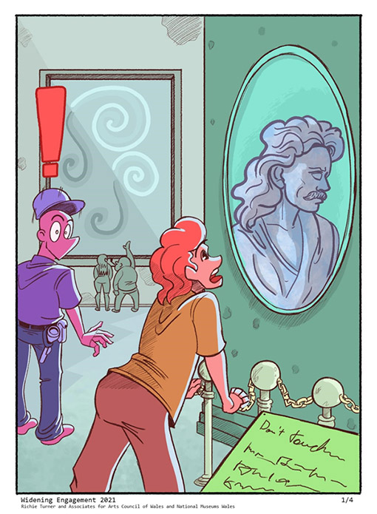
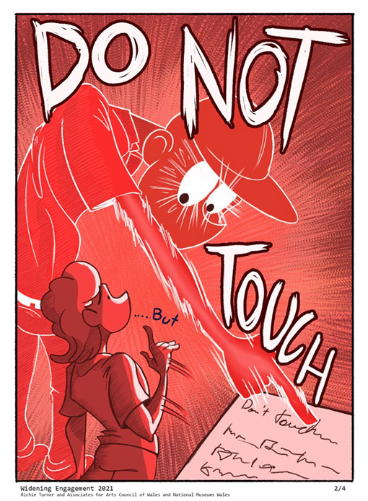
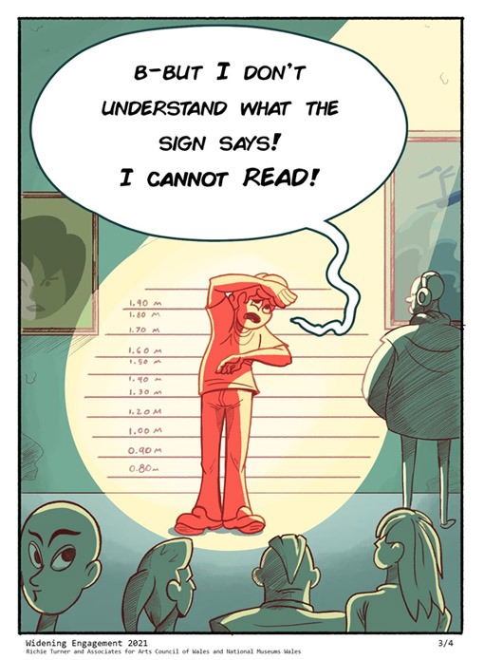
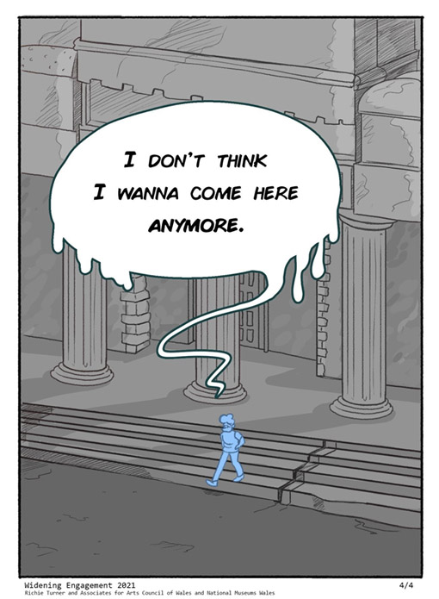
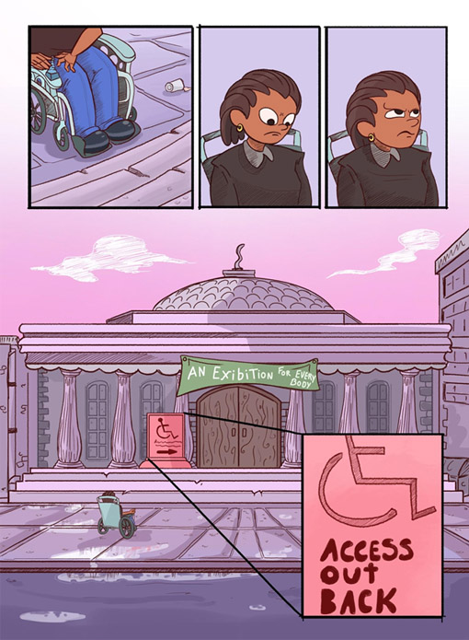
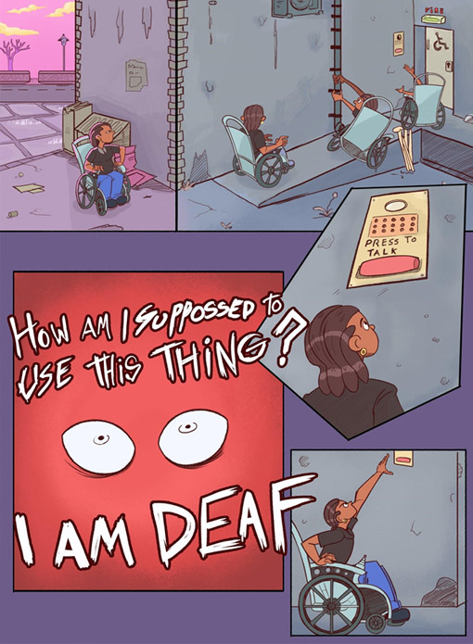
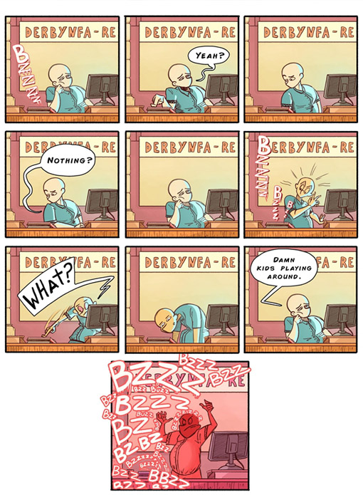
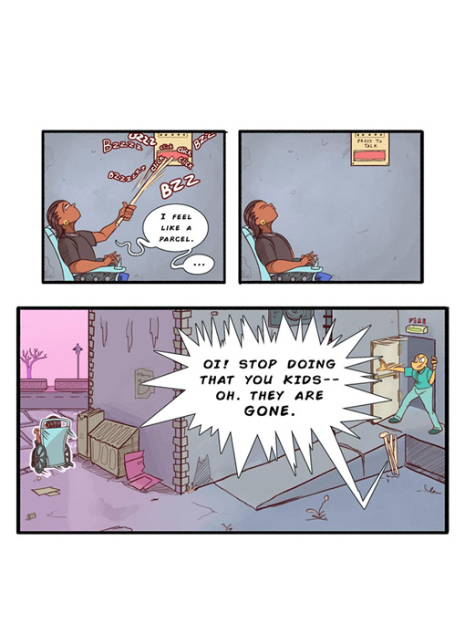
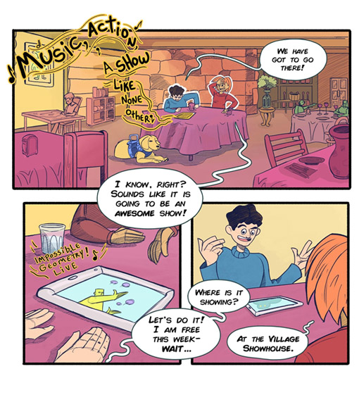
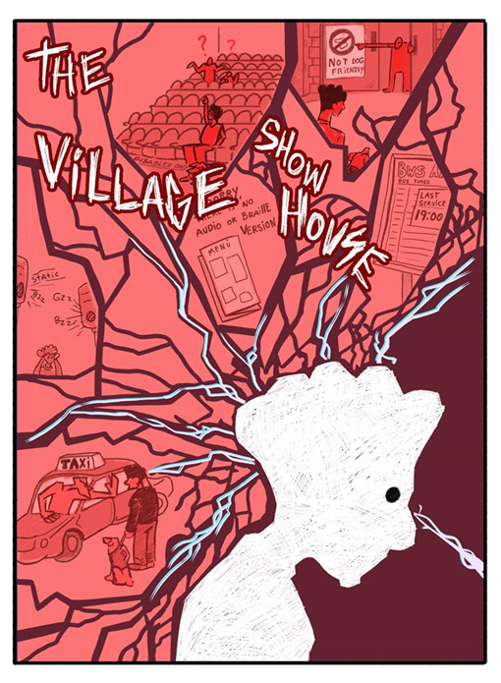
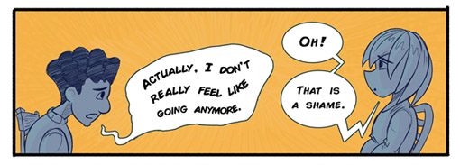
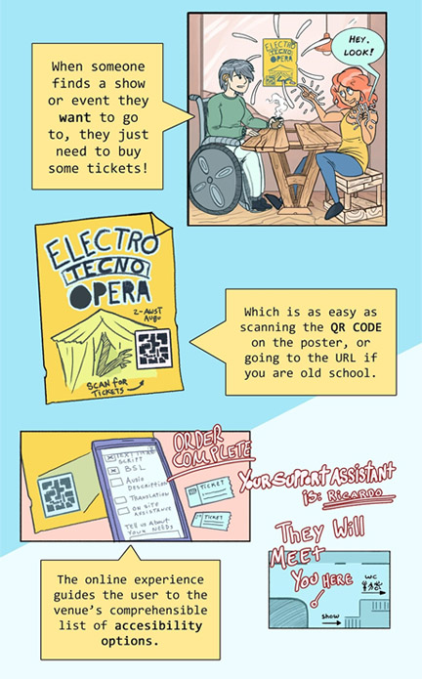
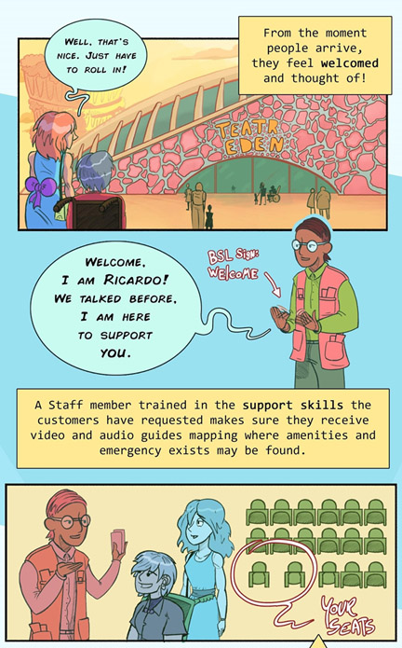
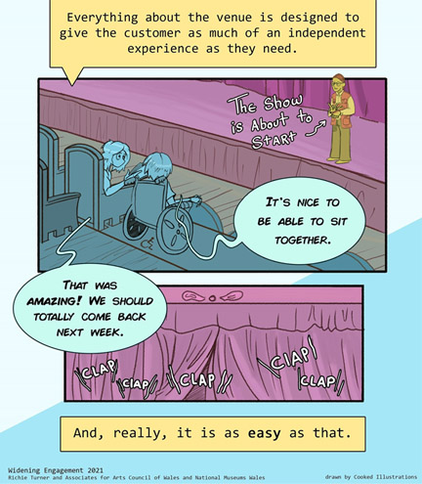

https://seearoundbritain.com/

