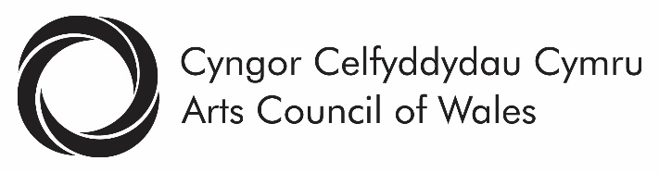
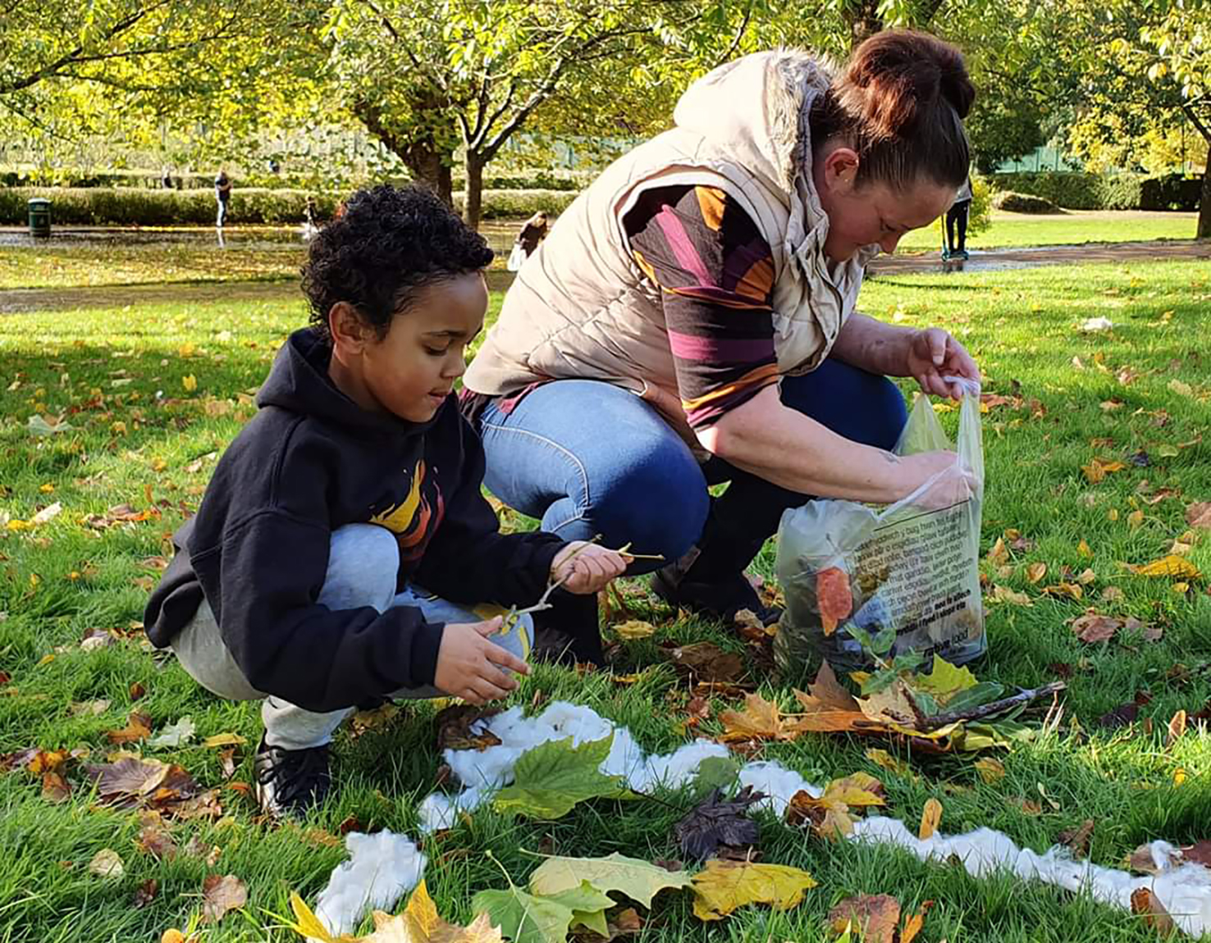
Arty Parky, Bedwellty Park, Head4Arts (image: Ryan Davies)

Arts Council of Wales

Strategic Equality Objectives 2020-24

Contents

Foreword 3
Arts Council of Wales Strategic Equality Objectives – Long Term Objectives 7
Actions 12
Application of the 5 ways of working – Future Generations Act Wales 20

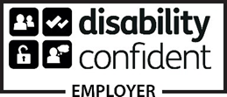

Arts Council of Wales makes information available in large print, braille, audio, Easy Read and British Sign Language. We’ll also try to provide information in languages other than Welsh or English on request.

Arts Council of Wales operates an equal opportunities policy.
Foreword
A generous, fair minded and tolerant society is instinctively inclusive. It values and respects the creativity of all its citizens. If we want Wales to be fair, prosperous and confident, improving the quality of life of people in all of its communities, then we must make the choices that enable this to happen. This is what the Strategic Objectives set out in this document are all about. Diversity strengthens and invigorates the arts.
The Public Sector Equality Duty sets out specific legal responsibilities for the public sector in Wales to support and help progress its equalities work. For the Arts Council of Wales, reporting is more than a legal requirement, it’s fundamental to the delivery of our core priorities. These priorities are set out in our corporate plan, “For the Benefit of All”. Publication of “For the Benefit of All” represented a major step forward. It sets out our ambitions and plans for increasing the number of people enjoying and taking part in the arts, targeting those people from communities and backgrounds that the arts in Wales still fail to fully represent.
Our “vision” is of a creative Wales where the arts are central to the life and well-being of the nation, making our country an exciting and vibrant place to live, work and visit. This means recognising the cultural entitlement and creative needs of all individuals and communities across Wales.
The world looks very different today than it did when published our Strategic Equality Plan 2017-21. We recognised then that change was needed across the arts in Wales – including at the Arts Council of Wales. For too long Black, Asian, Minority Ethnic people along with Deaf and Disabled people and artists have been denied opportunities to create and present their own art or to work in the arts in Wales on their own terms.
Our annual report for 2019/20 told us that although we were making progress with our targeted programmes and projects, in key areas of our work we were failing to reach the targets we had set four ourselves and for the arts in Wales.
We have been consistently failing to increase the number of people working in the arts in Wales who identified as deaf or disabled or came from a Black Asian Minority background. The same remains true of our own workforce. Similarly, our statistics showed that people from minority backgrounds are not represented on the management boards of those organisations we fund.
In addition to this, our funding data for 2019/20 told us that out of 173 applications received from 145 unique organisations to our Lottery funding programme only 9 were submitted by disability led organisations and 8 by organisations led by Black Asian Minority artists. The data for individual artists told a similarly disappointing story.
The end of this year, March 2020, saw the unprecedented and immediate impact of the Coronavirus/ Covid-19 crisis. The sudden onset of this global pandemic across the UK saw, in a single night, the suspension of all arts activities and a change in the living and working environment for everybody. The arts and cultural sector came to a standstill and this has continued well into 2020/21.
The emergence during this period of Black Lives Matter and the “WeShallNotBeRemoved” campaign brought into sharp focus the impact of structural racism and ableism that has been prevalent in the arts in Wales and in society as a whole.
The conversations that we have been engaged in during the 2020 have resulted in the Arts Council of Wales acknowledging structural inequalities within our own organisation and across the arts in Wales. In particular, we have recognised the pain and trauma that structural racism and ableism inflicts and acknowledged that power and privilege can be a serious barrier to equality, representation and inclusion.
The time for urgent anti-racist action, for structural and permanent change and for processes of truth and reconciliation is now. The Arts Council accepts its responsibility to make sure that this happens.
We made a clear commitment to change, set out in our Black Lives Matter statement and in our support of the Seven Inclusive Principles for the Arts that have grown out of the We Shall Not Be Removed campaign.
https://arts.wales/news-jobs-opportunities/black-lives-matter-0
https://arts.wales/news-jobs-opportunities/working-safely-through-covid-19-seven-inclusive-principles-for-arts
Our 2020-24 Strategic Equality Plan sets out the actions that we will take to make this change happen.

Arts Council of Wales Strategic Equality Objectives - Long Term Objectives
Long term objectives: | Why we have these objectives | Monitor / Evaluation | Who is responsible? | Longer Term Outcome
- Engage, consult and inform our partners and the communities we aim to reach and in so doing challenge and question our knowledge and experience. | We have recognised through the conversations we have been involved in throughout 2020, the importance of listening to the lived experience of those who have experienced structural inequalities across the arts in Wales. Continuing to engage with those experiences is the only way we will bring about change.  Working alongside artists, partners and communities, being informed and challenged by them has to be central to our work moving forward; as does being open and transparent in communicating our successes, our failures and our ongoing challenges. | We will collect and collate information on discussions that have taken place and the changes that have resulted from those discussions.  We will report on and evaluate the impact of specific projects and events, focussing on how these have influenced change in policy, process and delivery.  We will report on and evaluate progress and change resulting form working in partnerships with specific , detailing aims and objectives and the impact on our work. | Senior Leadership Team is responsible for driving this objective forward. They in turn will be held to account by the Equalities Committee and will report on progress to Council. | We will collect and publish evidence that demonstrates all our policy and programme development is informed by the artists and people whose experiences of engaging in the arts in Wales we are seeking to transform.  Involving people with protected characteristics and from minoritised communities will be built into the development of projects, the drafting of guidelines and our decision-making processes.
- Develop a workforce that reflects the diversity of Wales by increasing the number of people with protected characteristics employed in the arts and represented in the governance of arts organisations. | We are failing to bring about substantive change in diversifying the workforce and boards of management of those organisations we fund in the Arts Council itself. | We will collect and analyse data from our Arts Portfolio Wales survey and application and completion forms submitted by Lottery applicants (individuals and organisations).  We will review progress made by our Arts Portfolio Wales organisations on an annual basis through the Arts Funding Agreements and submission of strategic equality plans. The APW organisations will be required to set targets and report on progress towards achieving these.  We will collect and analyse data on our internal recruitment, professional development and progression processes. This data will be reported to and reviewed by our HR and Renumeration Committee and our Equalities Committee.  We will provide monitoring reports on all our procurement activity. | Senior Leadership Team is responsible for driving this objective forward. They in turn will be held to account by the Equalities Committee and will report on progress to Council. | We will have doubled the percentage of disabled people and people from Black Asian Minority Ethnic backgrounds in the arts workforce.  We provide evidence of the impact of programmes we have supported and co-created to increase the number of people from minoritised communities working in the arts.  We will have trebled the number of people from these backgrounds on boards of governance.
- Work to eliminate pay gaps across the arts sector and ensure fair and equal pay for all artists working in Wales. | Evidence from across the arts sector and the public sector more widely shows us that fair pay and pay equality continues to be an issue. | We will collect and analyse data from our internal HR systems.  We will provide reports to our Equalities Committee on the state of pay across the sector, particularly in relation to freelancers.  We will monitor progress through an annual Creative Professionals survey and through a new section in the APW survey asking for data on working with contracted and freelance artists. | Senior Leadership Team is responsible for driving this objective forward. They in turn will be held to account by the Equalities Committee and will report on progress to Council. | We will have established effective processes and plans for monitoring and addressing pay gaps, that include reporting on training and progression within the Arts Council and across the sector we support.  We will have developed and support a National approach to fair and equal pay across the sector, specifically for those working in the arts as freelancers.
- Increase the number of diverse artists and arts organisations accessing funding and support to create and present their own art on their own terms. | It’s clear from reviewing progress that change needs to happen at all stages of our Lottery funding process. Inequalities exist in how people access information, how they access support and how the funding is distributed. | We will review and report on applications and awards made through our Lottery funded programmes and strategic projects.  This will include data collection in relation to people leading and accessing arts activity and evaluation of the impact of specific projects on engagement of artists and communities from protected characteristic groups. | Senior Leadership Team is responsible for driving this objective forward. They in turn will be held to account by the Equalities Committee and will report on progress to Council. | We will be able to demonstrate and evidence that all of our funding programmes are open and accessible to all artists and organisations.  We will be reporting an increase in the number of artists, arts organisations and projects we support that reflect the lived experience of the diverse population of Wales.  This change will be reflected in the projects funded through our Lottery programme and Arts Portfolio.
- Increase the diversity of those engaging with the arts as audience members and creative participants. | Our evidence tells us that whilst progress has been made in some areas, the arts in Wales still fail to reach significant parts of our communities, social and geographic. | We will collect and analyse data from our Arts Portfolio Wales survey and application and completion forms submitted by Lottery applicants (individuals and organisations). This will include data collection in relation to people leading and accessing arts activity and evaluation of the impact of specific projects on engagement of artists and communities from protected characteristic groups.  We will analyse and report on data collected through the Audience Agency which reports on audience engagement.  We will continue to be part of the Wales National survey which includes questions about arts and culture.  For the first two years of the plan we will support and initiate research and surveys that collect data specific relating to arts engagement during the Covid pandemic. These will include for example the Indigo Survey. | Senior Leadership Team is responsible for driving this objective forward. They in turn will be held to account by the Equalities Committee and will report on progress to Council. | We will evidence an increase in the number of people from minoritized communities and those with protected characteristics attending and participating in the arts.  There will be a narrowing of the gap between those in the most and least affluent social sectors as audiences and creative participants.

Actions
Actions 2020/21 | Lead | Actions 2021/22 | Lead | Longer Term Actions | SEP Objective
Establish within a matter of weeks a series of conversations between Council and artists from Black and other minority ethnic backgrounds, as well as our many disadvantaged communities. We will do this to share their experiences of living and working in Wales (ensuring that these voices are at the forefront of short-term and long-term actions for change).  Work with communities in all parts of Wales to develop and publish a Covid-19 recovery plan that has equalities at its heart and which requires our Arts Portfolio Wales (APW) organisations to do the same.  Upgrade our advisory Equalities Monitoring Group to a full Committee of the Arts Council, ensuring that Council itself better reflects the lived experience needed to represent 21st century Wales. | Director Arts Engagement  Senior Leadership Team  Director Arts Engagement | Schedule a conference to provide a public platform for these important discussions, for truth and for reconciliation.  We will continue to work in partnership with a group of public sector bodies on the delivery of our shared equality objectives, working together to drive forward change across the sector. | Director Arts Development/ Head of Communications and Public Affairs  Director Arts Engagement | To take part in continuous processes of dialogue and learning, challenging ourselves and our institutional culture.  Making these processes transparent, inclusive and led by voices with lived experience.  We will continue to build on the successful work undertaken during the previous plan in our communications policy and processes. Our new website provided a significant step forward and all PDF documents on our website are accessible to screen readers. Our social media content and all future information, including funding guidelines, will continue to be subtitled in both Welsh and English and made available in alternative formats including BSL. | Engage, consult and inform our partners and the communities we aim to reach and in so doing challenge and question our knowledge and experience.
Create a new staff post to act as an “Agent for Change”. This will be a senior role at the Arts Council with a mandate to drive change within our organisation.  Drawing on the skills and experience of an Agent for Change, strategic partners and individuals, both internally and externally, we’ll look closely at how we’re perceived as an organisation and develop actions to address this. We’ll move forward with our apprenticeships and actively recruit. | Director Arts Engagement  Director Arts Engagement | Identify and resource appropriate support for APW organisations to diversify their governance, workforce and programmes of activity, placing greater emphasis on inclusion.  We’ll improve how we monitor both the implementation and the impact of our funded organisations’ equality action plans. We’ll explore with our APWs how these could be published. We will examine our approach to collecting data form our APWs and link this work more closely with the monitoring of their action plans.  We will develop our plans for a Wales Change Maker programme.  We’ll change our own Board culture by creating a working group to explore how we can be less formal.  We will develop and launch new Terms of Reference for the postponed Investment Review which will have equalities as a key focus for change.  We will work with the Welsh Government to develop a Cultural Contract and require our APW’s to adopt these as part of their funding agreement with us.  We will re-visit our plans to support BECTU to roll out the theatre diversity action plan.  We will deliver our targeted programmes around work force development in partnership with Weston Jerwood and our work with Creative & Cultural Skills, and through our Ffolio and Horizons programmes. | Directors Arts Engagement and Arts Development  Evaluation and Research Manager  Portfolio Manager  Chair and Senior Leadership Team  Director of Operations  Directors Arts Engagement, Arts Development and Director of Operations  Portfolio Manager  Portfolio Managers | We will change our approach to how we recruit, working with partners across the public sector and those with the lived experience we aim to attract.  This will involve a wholescale review of how we present ourselves, our application process and our interview process.  We will review and develop our approach to training and development for our staff. | Develop a workforce that reflects the diversity of Wales by increasing the number of people with protected characteristics employed in the arts and represented in the governance of arts organisations.
We will review and report on our own pay information, identifying pay gaps and agreeing actions to address these.  We will engage in conversations around the development of fair pay to artists in Wales.  We will adopt an approach to ensuring individual artists’ contribution to the development of our work is appropriately remunerated. | Head of Human Resources  Director Arts Development  Senior Leadership Team | We will establish and implement actions to address pay gaps within our own organisation.  We will develop and implement a more structured approach to how we monitor and report on procurement across the organisation, ensuring fair and equal access to the services we contract. | Head of Human Resources  Planning, Performance and Compliance Manager |  | Work to eliminate pay gaps across the arts sector and ensure fair and equal pay for all artists working in Wales.
To revise our National Lottery applications process and assessment criteria to ensure that our funding reaches further into all the communities of Wales.  To learn from the success of our recent Covid-19 emergency response funds, which achieved greater and more diverse reach than any of our previous programmes, to ensure this becomes the norm.  We will support the development of organisations led by Deaf and Disabled artists and Black, Asian and Ethnically diverse artists through our Creative Steps programme.  We will develop and launch a strand within Creative Steps that will support the development of individual artists. | Director of Operations  Director of Operations  Director Arts Engagement  Director Arts Engagement | We will draw on knowledge and expertise elsewhere to explore how we encourage applications from more diverse organisations and individuals and how we support applicants through to success. We will consider how we bring a more diverse range of experiences into our decision making and develop a new approach to how we monitor where our funding goes and the impact it has.  We’ll continue our work around reviewing and revising our approach to research.  We will deliver our targeted programmes that support the development of artists and arts organisations that are the focus of this plan.  These programmes will include:  Creative Steps, Unlimited, Sharing Together, Ramps on the Moon and International. | Director of Operations  Evaluation and Research Manager  Portfolio Managers | We will continue to monitor and revise our processes as required. | Increase the number of diverse artists and arts organisations accessing funding and support to create and present their own art on their own terms.
We will develop and publish a Covid Recovery plan which has embedded within the 7 Inclusive Principles for the Arts, ensuring that all activities comply with the Equality Act, that ableism and racism are eliminated in the arts and that incorporates the concepts of co-production and co-creation.  We will commission work to engage with communities we have identified as not being reached and publish the outcome of this work before the end of the year. | Chief Executive  Director Arts Engagement | We will review the impact of Covid-19 on our Hynt scheme and secure and further develop the scheme across Wales.  We will re-launch our Night Out community scheme.  We will develop a widening engagement programme based on the outcome of the commissioned work undertaken in year 1 of this plan.  We will deliver our Arts and Health and Creative learning programmes in line with our corporate objectives and the delivery of this plan.  We will align key elements of our International Programme with the objectives contained within this plan.  We will align our Equality and Welsh Language plan objectives to better reflect our integrated approach in line with the expectations of the Future Generation Act Wales. | Portfolio Manager  Head of Night Out  Portfolio Manager  Portfolio Manager  Programme Manager Creative learning  Head of Wales Arts International  Portfolio Managers and Senior Leadership Team |  | Increase the diversity of those engaging with the arts as audience members and creative participants.

Application of the 5 ways of working – Future Generations Act Wales
Ways of working | How this has been applied
Prevention | The objectives have been informed through understanding inequality insight evidenced through ‘Is Wales fairer’ – The state of equality and human rights, the Equality and Human Rights Commissions review of the public sector equality duty, 2019 and information from our annual report 2019-20.
Long term | The high-level objectives are recognised as long-term objectives that will exist beyond the four-year cycle of the SEP. The plan recognises that long term commitment to delivery and resourcing is essential to bring about the substantive change needed.
Collaboration | We are working in partnership with a group of 11 Public Bodies united behind shared objectives and committed to working together to meet the objectives. Partnership bodies have signed a ‘memorandum of understanding’ which outlines their commitment to collaborative working. Through this partnership we will support and learn from each other and hold each other to account.
Integration | The high-level objectives have been informed through insight, they align to Welsh Government long term equality aims and contribute to a more equal Wales (FGA) and a fairer society (Equality act, 2010). Application of the five ways of working has supported integration across duties.
Involvement | Conversations with stakeholders and recipients of public services informed the development of this and the public bodies shared plan. We are committed to engagement with people and communities in the further development of the plan and the design of projects, programmes and services that drive our objectives forward.

